3 WGI 13-204 IC-1 27 July 2015

THIS COPY OF WING INSTRUCTION 13-204 IS A CONDENSED VERSION OF THE ORIGINAL. IT WAS CLEANED FOR WEB SITE USE. THE AERO CLUB HAS AN ORIGINAL COPY ON FILE FOR ANY MEMBER WHO WISHES TO READ IT.

THIS VERSION WILL ALLOW YOU TO ANSWER QUESTIONS IN OUR STANDARDIZATION TEST.

Section A--General Airfield Information/Procedures

- General Airfield Information. Elmendorf Airfield has two active runways, Runway 06/24 and Runway 16/34. Runway 06/24 is 10,000’ x 200’ and Runway 16/34 is 7,500’ x 150’ with a 500’ stressed displaced threshold at the approach end of Runway 34 usable for Runway 34 departures only. This displaced threshold can be accessed via the South Loop and provides 8,000’ of departure runway surface for Runway 34 only. All Elmendorf taxiways are 75’ wide. A helipad is located on Taxiway J, between the Western-end of Hangar 11 and Taxiway B. The Elmendorf Airfield field elevation is 212’ mean sea level (MSL).

  - Navigational Aids (NAVAIDS). Elmendorf Airfield has a tactical air navigation (TACAN), instrument landing system (ILS) and precision approach radar (PAR). ILS and PAR approach capabilities are available for use to Runway 06 only.

1.2. Runway 06/24. Runway 06 is the primary instrument runway and has a +0.16% gradient. Runway 06 is equipped with approach lighting system with sequenced flashing lights (ALSF-1), high intensity runway lights (HIRLS), touchdown zone lights (TDZL), precision approach path indicator precision approach path indicator (PAPI), and centerline lights. Runway 06 has a 4,000’ by 90’ assault landing zone painted 2,500’ from the approach end of Runway 06. Runway 24 is equipped with HIRLS, PAPI and centerline lights. Runway 24 has a 4,000’ by 90’ assault landing zone painted 3,500’ from the approach end of Runway 24. Runway 06 has a +0.16% gradient and Runway 24 has a -0.16% gradient. The first 1,000’ of Runway 06 is concrete and the first 1,200’ of Runway 24 is concrete. The middle section (7,800’) of Runway 06/24 is asphalt.

1.3 Runway 16/34. Runway 16/34 is equipped with HIRLS, PAPI, and assault landing zone (ALZ) overt/covert lights. Runway 16 has a -0.3% gradient. Runway 34 has a +0.3% gradient. Runway 16/34 has a 4,000’ by 90’ assault landing zone painted 1,750’ from the approach end of Runway 16 and 1,750’ from the approach end of Runway 34. Overt lighting for the ALZ is available to Runway 34 and overt or covert lighting is available to the ALZ for Runway 16. Runway 16/34 is asphalt.

Figure 1.1. General Airfield Layout.
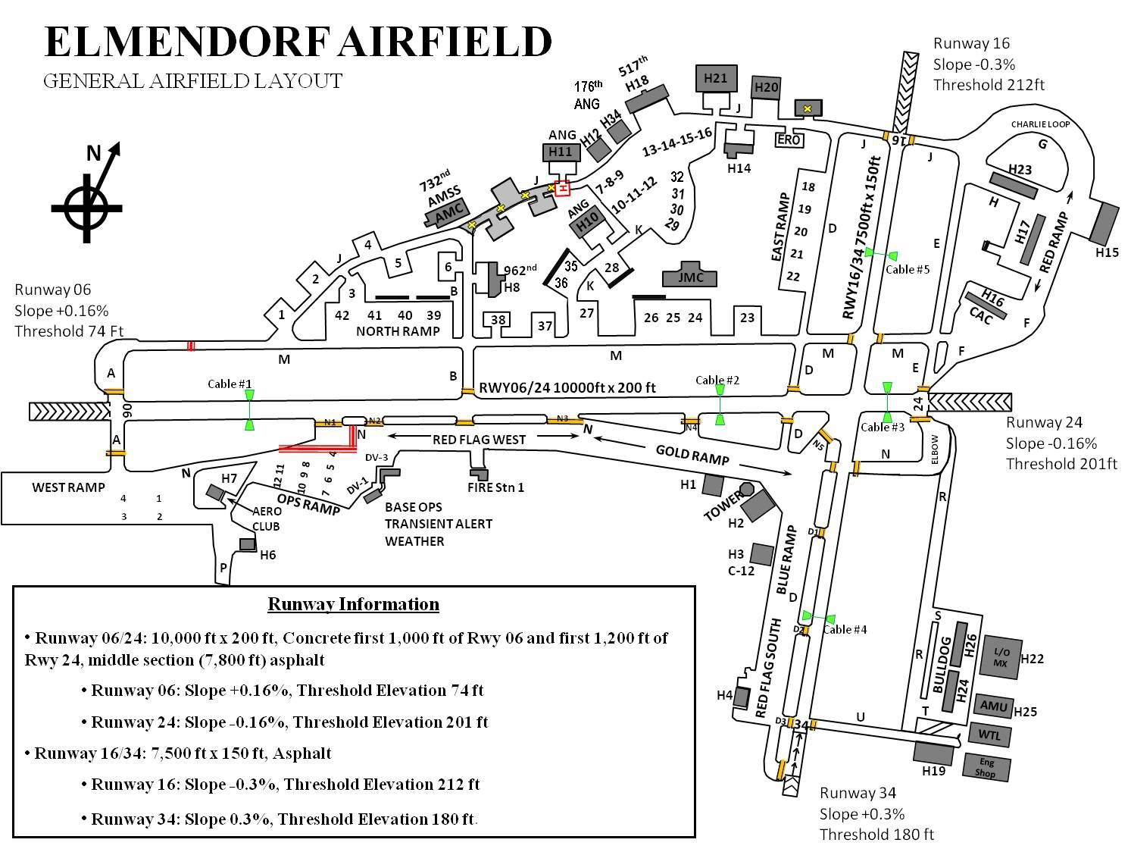

1.4. Airfield Operating Hours. The Elmendorf Airfield is open 24/7. The Air Traffic Control Tower and airfield management (AM) are open 24/7. Radar final control (RFC) hours of operation are published by notice to airmen (NOTAM) weekly.

Wind Information:

  - Surface winds will be issued when clearing aircraft for takeoff, when clearing an aircraft to land, touch-and-go, stop-and-go, for low approach, or for the option. The landing runway will always be restated.

  - Wind direction and speed will be issued from airfield automation system (AFAS) wind displays. When wind displays are unavailable, wind information contained in the latest weather sequence will be used and will be prefaced with the term “ESTIMATED.”

  - Variable wind criteria will be issued with wind information when applicable (changes in wind direction of 60 degrees or more when the wind speed is 6 knots or more). EXAMPLE: WIND THREE ONE ZERO AT ONE FIVE, VARIABLE BETWEEN TWO SEVEN ZERO AND THREE FOUR ZERO.

  - Wind sensors will be selected for the approach end of the runway in use unless operational advantage will result from an alternate setting. Pilots will be advised if reported winds are from a location other than the approach end of the runway. Runway 16/34 does not have wind sensors at either end of the runway. Tower will use the Runway 24 sensor and the word, “ESTIMATED” when providing winds for Runway 16/34 operations.

- Areas Not Visible from the Tower. The following areas are not visible from the Tower: Spot 1 on the West Ramp; distinguished visitor (DV)-1 and portions of the Ops Ramp directly behind airfield management operations (AMOPS); Taxiway (Taxiway) B from the 962 AACS Hangar to Taxiway J; the C-130/C17 Ramp Area and Taxiway K directly behind the Joint Mobility Compound (JMC) facility extending to Hangar 18; the heli-pad directly behind Hangar 10, Red Ramp Area behind Hangar 23, Bulldog Ramp directly behind Hangars 24 and 26, Taxiway F directly behind the combat alert cell (CAC) to Taxiway H; and the areas immediately in front of Hangars 1, 2, 3 and 4.

Figure 3.1. Tower Blind Spots.
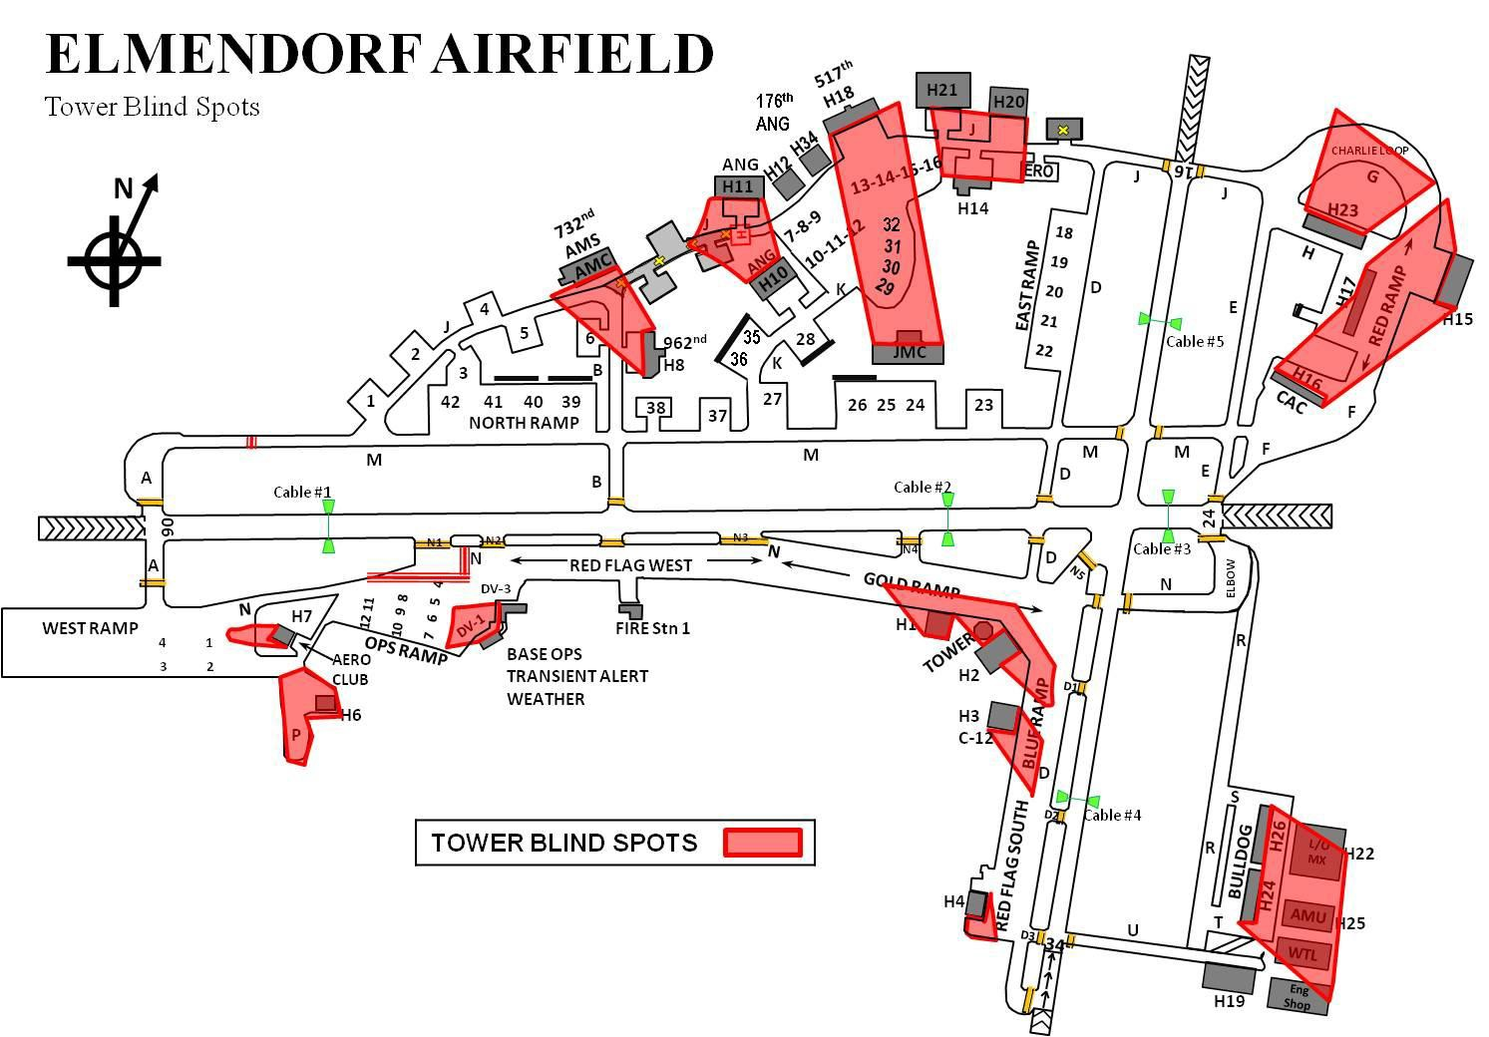

8

- Runway Selection Procedures. The ATC Watch Supervisor will use the criteria outlined below to determine the runway in use, but may, in the interest of safety and/or to maintain an expeditious and orderly flow of traffic, deviate from this criteria.

  - When the tailwind component is 10 knots or less, Runway 06 will be the runway in use.

  - When the crosswind component exceeds 10 knots, the runway most nearly aligned with the wind will be in use. NOTE: Fighter-type aircraft will, to the maximum extent possible, depart from Runway 34 and arrive to Runway 06. This traffic flow minimizes complex opposite direction operations and enhances safety of flight within the Elmendorf Class D.

  - When the ceiling and/or visibility are below published circling minimums, wind direction and speed will not be the sole determining factor for choosing the runway in use. Due to snow operations, end of runway (EOR) areas may not be cleared and runway use may be determined by cleared areas on the airfield.

  - Tower will notify RFC, Anchorage Approach Control (A11), Airfield Management Operations, and the weather observer prior to changing the runway in use and will document the change on the AF Form 3616, Daily Record of Facility Operation.

  - AMOPS will notify Command Post, Barrier Maintenance, Fire Department, Transient Alert, and Roads and Grounds of the runway change.

- Controlled Movement Areas (CMA). The controlled movement area is defined as the runways and overruns to include an area no less than 100’ extending out from each side of the runways and overruns, Taxiway M West of the Instrument Hold Line (located in between Taxiway J and Alpha North), Taxiway A-North, Taxiway Alpha South (north of the instrument hold line), and Taxiway N (inside the instrument hold lines between N2 and the Ops Ramp), and the access road leading to Cable 1. Personnel and vehicles MUST obtain Tower approval prior to entering the CMA and will maintain two-way radio contact with the Tower at all times while within the confines of the CMA. CMA entry access/exit procedures can be found in the 3WGI 13-213, Airfield Driving Instruction.

Figure 5.1. Controlled Movement Area Map.
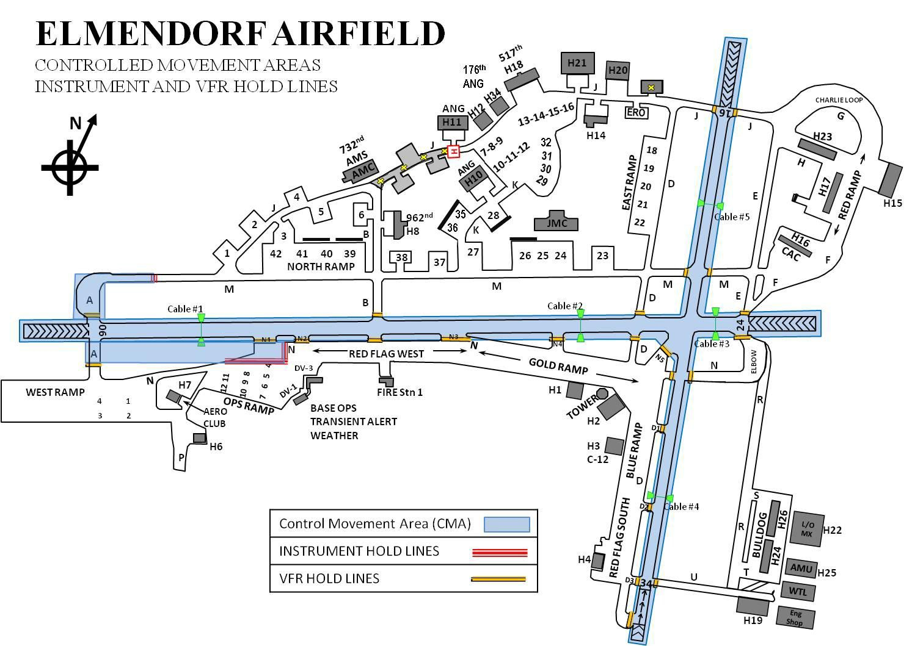

  - Airfield Vehicle/Pedestrian Operations. Vehicles and pedestrians may operate on aprons, ramps, and taxiways without Tower approval. Tower approval MUST be received prior to operating within the CMA. For a comprehensive explanation of vehicle/pedestrian airfield driving procedures, refer to 3WGI 13-213. NOTE: With Tower approval, Power Production and Barrier Maintenance personnel may perform necessary duties in the arresting system pit areas. Approval from the Tower for this operation does not constitute approval on any runway surface and Barrier Maintenance vehicles will remain behind the Barrier Arresting Kit-12 (BAK-12) system housings.

Airfield Lighting Systems/Procedures:

  - All airfield lighting will be operated in accordance with Federal Aviation Administration Order (FAAO) 7110.65, Air Traffic Control, with the following exceptions:

10

    - To prevent freezing of airfield lighting lenses, the touchdown zones, PAPI, assault landing zones and centerline lights will not be turned off for a period greater than 6 hours during local National Geospatial-Intelligence Agency (NVG) training. At all other times, these lights will remain on a minimum of Step 2 when the temperature is at or below 35 degrees Fahrenheit.

    - All runway and approach lights will be turned on a minimum of Step 2 during periods of active snowfall and/or ice fog.

    - PAPI lights will be set on Step 4 for daytime operations and Step 3 for nighttime operations, unless otherwise requested by the aircrew or as deemed necessary by Tower. PAPIs need not be operated during hours of darkness when no aircraft are inbound.

    - During snow removal operations, the runway, taxiway, and approach lights will be turned on for snow equipment operators to see and avoid the lights.

  - When Runway 06/24 is the active runway and the lights are required to be on, only those lights will be turned on. When Runway 16/34 is the active runway and the lights are required to be on, both Runways 06/24 and 16/34 lights will be turned on. Approach and runway light intensity settings will be in accordance with FAAO 7110.65.

  - Taxiway lights will be operated in accordance with FAAO 7110.65 with the following exception: During the hours of darkness and/or periods of snowfall, the taxiway lights will be turned on when snow removal is in progress, as requested by Equipment 44 or when aircraft towing operations are in effect.

  - Sequence flashing lights (SFL) will be operated in accordance with FAAO 7110.65. SFLs will be turned on prior to aircraft reaching 10 miles from touchdown.

  - Airfield Lighting will perform nightly inspections Monday through Friday from 0001L – 0800L and will report any airfield lighting discrepancies immediately to AMOPS.

  - Tower will notify AMOPS of any lighting issues. AMOPS will then notify Airfield Lighting of the discrepancies. However, if Airfield Lighting is on the airfield, Tower may notify Airfield Lighting of the issues, and then notify AMOPS of the discrepancies.

Permanently Closed/Unusable Portions of the Airfield:

  - Taxiway J, between Taxiway B and the West side of Hangar 11, is closed/unusable to all aircraft operations.

  - Taxiway P, South of Fighter Drive, is closed/unusable to all aircraft operations.

Figure 7.1. Closed/Unusable Portions of Airfield.
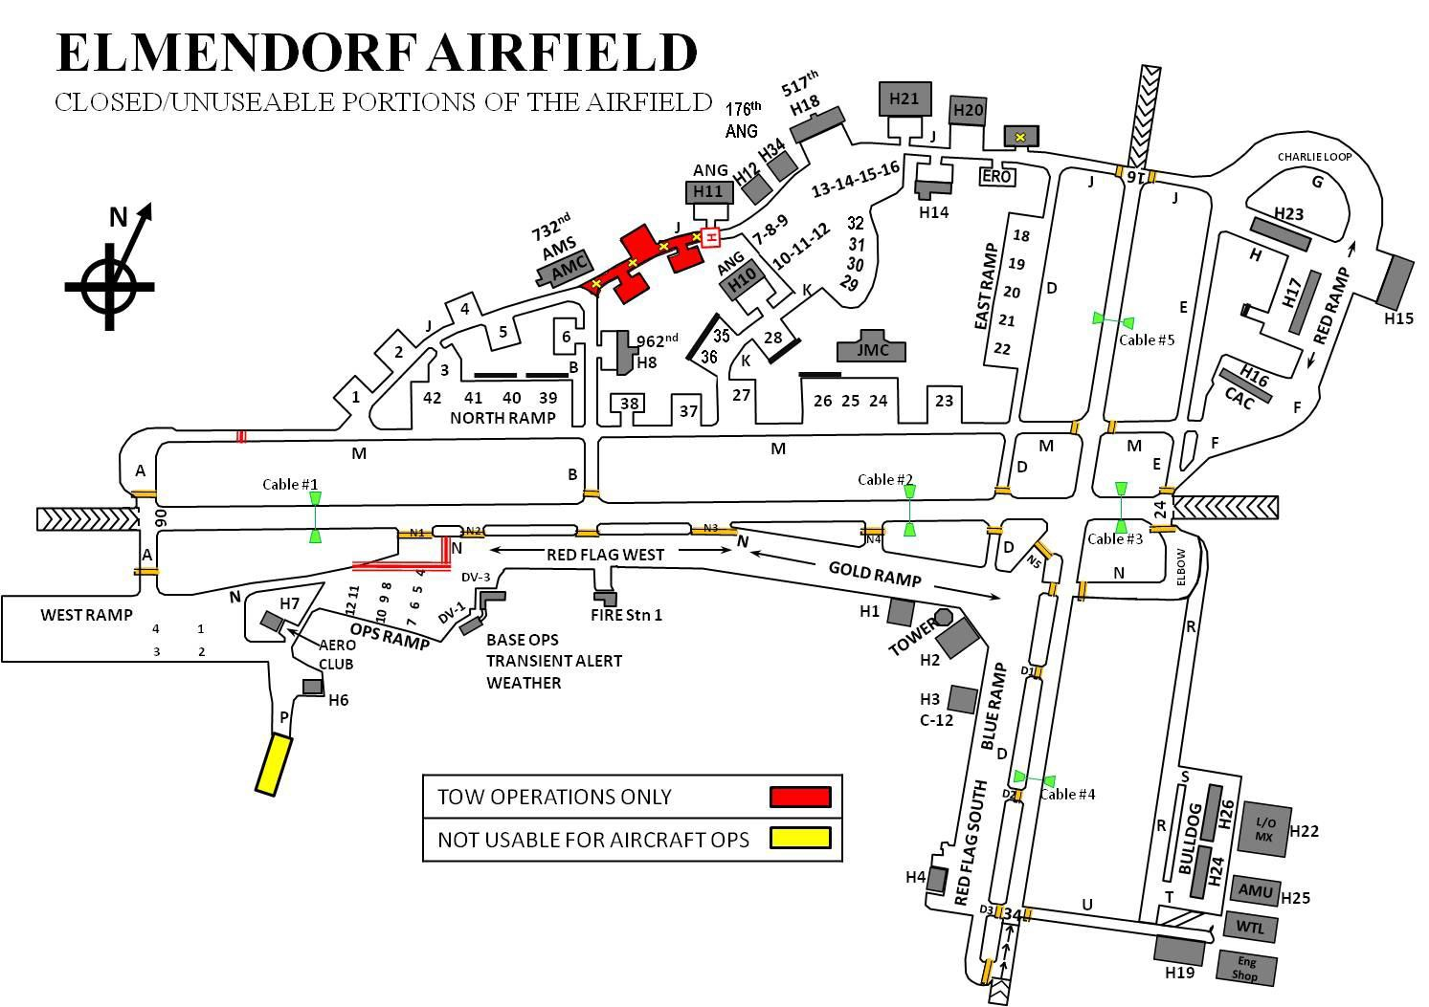

- Aircraft Arresting Systems. Each arresting system will be referred to by its number designator. Each cable is assigned a consecutive number starting at the approach end of Runway 06 through the departure end of Runway 34. All Elmendorf Airfield arresting systems are BAK- 12s. BAK-12 system designations and locations are listed below.

  - Cable 1 – 1,780’ from approach end of Runway 06 and 8220’ from approach end of Runway 24.

  - Cable 2 – 7,455’ from approach end of Runway 06 and 2545’ from approach end of Runway 24.

  - Cable 3 – 9,438’ from approach end of Runway 06 and 562’ from approach end of Runway 24.

  - Cable 4 – 6,005’ from approach end of Runway 16 and 1500’ from approach end of Runway 34.

12

  - Cable 5 – 1,500’ from approach end of Runway 16 and 6005’ from approach end of Runway 34

  - Standard Arresting System Configuration. Standard airfield cable configuration during the wing fighter flying window for Runway 06/24 will be Cables 1, 2 and 3 connected. For Runway 16/34 operations Cable 5 will be connected and the supervisor of flying (SOF) can request Cable 4 to be strung if deemed necessary. Outside the Wing Fighter Flying Window Cable 2 and 5 will be removed. Unique circumstances will be coordinated through the 3rd Operations Support Squadron Top 3 or the Airfield Manager.

  - Cable configuration priorities are as follows:

    - Cable 1.

    - Cable 3.

    - Cable 2.

    - Cable 5.

    - Cable 4.

  - Winter Arresting System Configuration. During the wing fighter flying window and at the start of snowfall, freezing rain or sleet, AM will immediately coordinate with the SOF and Barrier Maintenance to remove all cables for snow removal operations. During the wing fighter flying window, once snow removal has been completed AM will coordinate with the SOF and Barrier Maintenance to configure applicable cables for wing fighter flying. If snow removal is completed outside of the wing fighter flying window, Cable 1 will be connected immediately to enable alert launch capability. Cable 3 will be connected immediately following an alert launch if it’s not already connected (this configuration will be used from 15 Oct – 15 Apr ).

  - Due to aircraft specifications and published technical orders, cables may need to be removed to allow safe operations for certain aircraft. During the wing fighter flying window AM will coordinate with the SOF to de-conflict arrivals/departures with ongoing operations. AM personnel will check the Air Mobility Control Center (AMCC) schedule for any arrivals/departures and coordinate with the SOF for the removal of Cable 2, when required. AM personnel will notify AMCC of any operational issues as soon as possible.

  - All changes to airfield cable configuration during fighter operations will be coordinated through the SOF and AM.

  - No departures will be authorized over a loose, tripped or disconnected cable without 3 OG/CC approval, except for real-world North American Aerospace Defense (NORAD) Alert Launches. Aircraft may taxi past a loose/tripped cable prior to takeoff.

  - Except for emergency aircraft, landings are not authorized over loose, tripped or disconnected approach end cables if aircraft have the ability to hold. Loose/tripped departure end cables do not present the same hazard and should not result in a closed runway. If a cable is tripped, the Tower will notify AM who will in-turn notify Barrier Maintenance to reset the cable. The SOF may authorize aircraft to land with a loose/tripped cable with 3 OG/CC approval.

- Parking Plan/Restrictions. AM is the overall approval authority for aircraft parking and will use this authority to accomplish the 3 WG mission or in accordance with directives received from the 3 OG/CC. The following areas on the airfield have restricted access for parking. Coordination for parking on the areas listed below will be accomplished through AM. AM will coordinate with the designated organization for parking.

9.1. Hardstands 13-16 and 32 -- 517 AS/176 WG (C-17).

9.2. Blue Ramp 8-10 -- 517 AS (C-12).

9.3. Hardstands 6 and 38 -- 962 AACS.

9.4. Hardstands 7-12 (Kulis Ramp), 28-31, 35 and 36 -- 176 WG (C-130).

9.5. Hardstands 1-5, 18-27, 37 and 39-42 -- 732 AMS/MOC.

  - Red Ramp -- 90 FS.

  - Blue Ramp 1-7 and 11-29 -- Red Flag Alaska or 3 OSS/OSAM.

  - Gold Ramp -- 3 OSS/OSAM.

  - Fighter Town East Ramp -- 525 FS.

  - Red Flag Alaska West Ramp and the Blue Ramp 1-15 and 17-29 -- 3 OSS/OSAM or Red Flag Alaska.

  - Ops Ramp and West Ramp -- AM. NOTE: Due to Runway 06 Clear Zone requirements, no aircraft will park West of Taxiway A South on the West Ramp.

  - West Ramp Spots 1 – 2 -- 3 OSS/OSAM.

14

  - West Ramp Spots 3 and 4 -- 732 AMS/MOC.

  - Army Ramp (Hangar 6 Ramp) -- AKRFC Operations.

  - Hangar 10/11 Apron -- 210 RSQ (H60).

  - Engine Running On/Off Load (ERO). The area South of the C-130 Engine Test Cell is not an aircraft parking spot. This area will be used by the 3 WG and 176 WG for aircraft engine running on/off loads.

Local ATC Frequencies:

10.1. Tower - 127.2/352.05/CH 2.

  - Ground Control - 121.8/275.8/CH 1.

  - Automatic Terminal Information Service (ATIS) - 124.3/273.5.

10.4. Radar Final Control (RFC) - 134.9/259.1 (Ch 16) or 271.3 (Ch 17).

  - Pilot to Dispatch (PTD) - 134.1/372.2.

  - Pilot to Metro - 346.6.

  - Single Frequency Approach - 327.1 (Ch 7).

10.8. Anchorage Departure - 118.6/290.5 (Ch 3) or 134.35/285.55.

10.9. Clearance Delivery – 128.8/306.925 (Ch 9).

- Navigational Aid (NAVAIDS). Elmendorf Airfield has a TACAN (Ch 81X), ILS (localizer 110.3, 3 degree glide slope), and PAR. ILS and PAR approach capabilities are available to Runway 06 only. Further information regarding these NAVAIDS can be found in the Alaska Supplement.

  - Radar and Airfield Systems Response Times: The 673 CS (Radar and Airfield Systems personnel) are on-duty Monday- Friday 0700-1600 local (excluding holidays) and will be on-call during all other times. On-duty personnel will be immediately available to respond to outages/impairments from their primary duty location. On-call personnel can be contacted via the 673 CS Air Traffic Control and Landing Systems (ATCALS) maintenance at all times and will respond to equipment outages within one hour of notification.

  - NAVAID Preventive Maintenance Inspection (PMI). No-NOTAM preventive maintenance times are published in the Alaska Supplement. Changes to published times must be approved by the 3 OG/CC and will be disseminated via NOTAM until updated in the Alaska Supplement. Refer to the 3 OG and 673 MSG ATCALS Operations Letter for establishment of No-NOTAM PMI times (a copy of this document can be requested from the Airfield Operations Flight).

- Auxiliary Power Generators. The 773 CES Power Production Shop will obtain tower approval prior to performing a preventive maintenance generator run on any of the following facilities: Control Tower (Building 11535), ILS Localizer, ILS Glideslope, TACAN, Ground to Air Transmit and Receive (GATR) Site, GPN-22 PAR (Building 76529). Power Production will obtain AM approval prior to performing a preventive maintenance generator run for Building 11369. The AM personnel will advise Weather and Transient Alert before giving Power Production approval to conduct a run. NOTE: All Elmendorf ATCALS facilities are equipped with auto start auxiliary generators or battery backups.

- Transient Alert. See the Alaska Supplement for Transient Alert services provided.

- Automatic Terminal Information Service (ATIS) Procedures. Elmendorf’s ATIS is available 24/7. In addition to weather information, the ATIS will broadcast runway status, runway condition readings (RCR), runway visual range (RVR), airfield advisories, weather advisories, weather warnings, night vision device (NVD) operations, and other pertinent information when appropriate. Specific ATIS procedures are outlined in the 3 OSS/OSAT OI 13-204, Air Traffic Control Operations.

Aircraft Special Operations Areas/Ramps:

  - Authorized Fighter Arm/De-arm Areas. The following locations are identified for use as arm/de-arm locations for fighter-type aircraft with Class/Division (C/D) 1.1, 1.2, 1.3 and 1.4 explosives only.

    - The Elbow. Aircraft will park on a 060-degree heading, parallel to Runway 06. This is the primary de-arm spot for Runway 06 operations and the primary arming spot for Runway 24 operations.

    - Taxiway F. Aircraft can be armed/de-armed at this location, and will park on a 210 degree heading for arming or a 030-050 degree heading for de-arm.

    - Taxiway E. Aircraft will arm/de-arm single file on the Taxiway E centerline. This is the primary arming location for Runway 16 operations and de-arm spot for Runway 34 operations.

16

    - West Ramp EOR. Aircraft will arm/de-arm on the lines on a 310-degree heading. This is the primary arming spot for Runway 06 operations and the primary de-arm spot for Runway 24 operations.

    - Taxiway A North. Aircraft de-arm on a 250-290 degree heading.

    - Taxiway D, West of Taxiway D3 at approach end of Runway 34. Aircraft will arm/de- arm on the lines, facing south. This is the primary arming area for Runway 34 operations and the primary de-arm area for Runway 16 operations.

    - Intersection of Taxiways D and N, North of Blue ramp. Aircraft will arm/de-arm on a 060-degree heading. This is a backup location in the event of taxiway or runway closures or low RCRs.

    - Taxiway N, west of N3. Aircraft will arm/de-arm single file on the Taxiway N centerline.

Figure 15.1. Arm/De-Arm Locations.
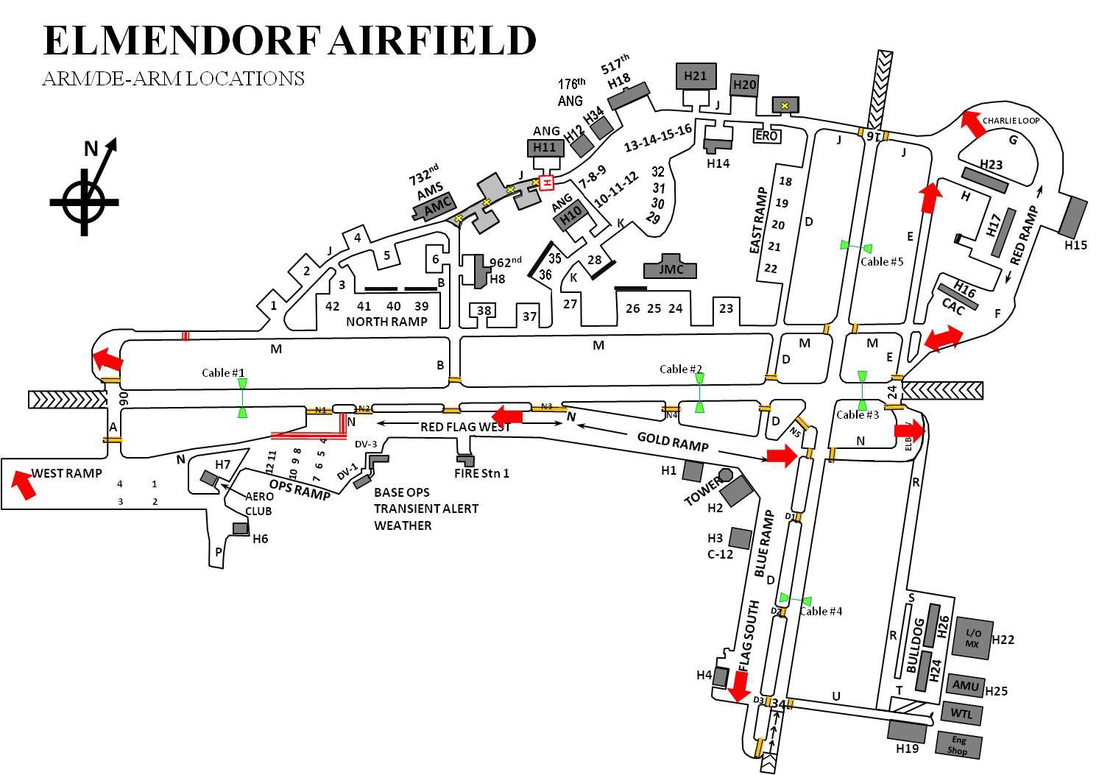

  - Authorized F-22 “Last Look” Locations. F-22 arm/de-arm operations are allowed in chocks in accordance with F-22 technical order directives. The following locations are identified for use as F-22 “Last Look” locations for use by F-22 aircraft.

    - West Ramp EOR: Aircraft will park on EOR lines on a 310-degree heading.

    - West Ramp Pits 1-4: Aircraft will park on Hot Pit lines on a 350-degree heading , spots will be used during hot-pit operations on the West Ramp.

    - Alpha North. Aircraft will face northwest on a 310-degree heading.

    - Gold Ramp Spots 18-27. Aircraft will park on parking spots on a 002-degree heading.

    - Red Ramp Spots 8-11: Aircraft will park on parking spots on a 90-degree heading.

    - Blue Ramp 24-29. Aircraft will park on parking spots on a 90-degree heading.

    - Blue Ramp North. Aircraft will park on EOR lines on a 90-degree heading.

    - East Ramp North. Aircraft will park on EOR line on a 210-degree heading.

    - The Elbow. Aircraft will park on a 060-degree heading, parallel to Runway 06.

    - Charlie Loops Spots 13-16. Aircraft will park on parking lines on a 110-degree heading.

    - In front of CAC. Aircraft will park on taxi lane lines on a 200-degree heading.

    - In front of Hangars 24 and 26 on taxi lane lines on a 270-degree heading.

    - axi lane Tango or Sierra on taxi lane lines on a 310-degree heading.

    - Taxiway uniform on taxiway lines.

  - Engine Run-Up Areas. Aircraft engine run-ups will be accomplished in accordance with AFI 11-218, Aircraft Movement and Operation on the Ground, appropriate supplements, and this instruction. C-17 aircraft will, to the maximum extent possible, conduct engine runs in reverse and may do so unrestricted. Engine runs not in reverse will use the following restrictions.

    - North Side Apron at the Approach EOR 06 (Alpha North). Unrestricted power is authorized provided prop/jet blast will not be directed across the runway or approach zone, unless approved by Tower.

18

    - West side Run-up area for Runway 16 (Taxiway J). Power is restricted to the minimum required for pre-takeoff checks. Prop/jet blast will not be directed across the runway or approach path.

    - South Side Apron at the Approach EOR 24 (Elbow). Power restricted to the minimum required for pre-takeoff checks. Prop/jet blast will not be directed across the runway, across Taxiway R or into the Approach Corridor. NOTE: The Elbow is limited to aircraft with wingspan less then Wingspan 170’.

    - Approach EOR 34 (four EOR spots). Unrestricted power settings are authorized for Categories I and II aircraft (prop driven less than 12,500 pounds gross weight). Power settings restricted to the minimum required for pre-takeoff checks for all other aircraft.

    - Hangar 17, 24, 26 and 23 (Flow Through). Minimum power to taxi.

    - Taxiway F, Charlie Loop and Alert Cell. Power restricted to 80 percent.

    - Blue and Gold Ramps. Jet and propeller engine runs, restricted to 80 percent power settings for one minute or less duration, may be accomplished on any Blue or Gold ramp authorized parking spot. C-12s may conduct unrestricted engine runs on any Blue or Gold Ramp parking spot.

    - Ops Ramp. Unrestricted power settings are authorized for Categories I and II aircraft (prop driven less than 12,500 pounds gross weight). Idle engine runs on Spots 4 through 12 and DV spots 1 and 3 will be limited to 5 minutes due to noise hazard to building occupants.

    - West Ramp and EOR. Prior coordination with AM is required for engine runs for Air Mobility Command (AMC) aircraft parked on the West Ramp. Power settings to 100 percent are allowed provided there are no fighter EOR operations in effect. Prop/jet blast will not be directed across Taxiway A South or the approach zone of Runway 06. Fighter EOR ops are authorized 100 percent settings.

15.3.10. Hangar 6 Ramp. Unrestricted power settings are authorized for Category I, Category II, and C-560 aircraft.

    - Hardstands 3, 5, 10 – 25, 27, 32 – 37, 41, and 42. Due to close proximity with buildings and work centers, only taxi/idle power will be authorized for these hardstands. This restriction applies to all Air Mobility Command (AMC), 517 AS, 962 AACS and transient aircraft. Aircraft will take all appropriate precautions to avoid directing blast towards other parked aircraft and across the taxiways.

    - Hardstands 1, 2, 4, 29, 30, and 31. Engine runs are authorized up to 100 percent power for prop driven aircraft. The aircraft must be facing the taxiway and the prop wash must be directed at the rear the hardstand. Vehicle and aircraft movement on the adjoining taxiway must halt when in the vicinity of the hardstand and aircraft are performing 100 percent power engine runs.

    - Hardstand 6. Due to close proximity with buildings and work centers, only taxi/idle power will be authorized on this Hardstand 6. When E-3 type aircraft request 100 percent power engine runs on Hardstand 6, all aircraft must be removed from Hardstand 5 prior to engine run.

    - Hardstands 28 and 38 – 40. Engine runs are authorized up to 100 percent power when directed at the blast fence.

    - Hardstand 21. Engine runs on Hardstand 21 require Airfield Manager approval and can be authorized up to 100 percent power with aircraft parked facing South on Hardstand 21. When engine runs are to be conducted on Hardstand 21, AM will close Hardstands 18-20 and the engine running offload (ERO) Spot for the duration of the engine run.

  - Air National Guard (ANG) C-130 or Transient Propeller Aircraft Propulsion Checks.
Options for conducting these checks are listed in the order of preference below.

    - Option 1. Conduct on the hardstand prior to taxi and in accordance with this instruction.

    - Option 2. If the weather is visual meteorological conditions (VMC), use Taxiway A North hammerhead with the aircraft facing East.

    - Option 3. On Taxiway M, West of Taxiway J, with the aircraft facing South-East to direct jet blast toward the grass on the North side of the taxiway.

  - C-12 Propulsion Check. Unrestricted propulsion checks are authorized on any designated parking ramp.

20

Figure 15.2. Engine Run Up Areas.
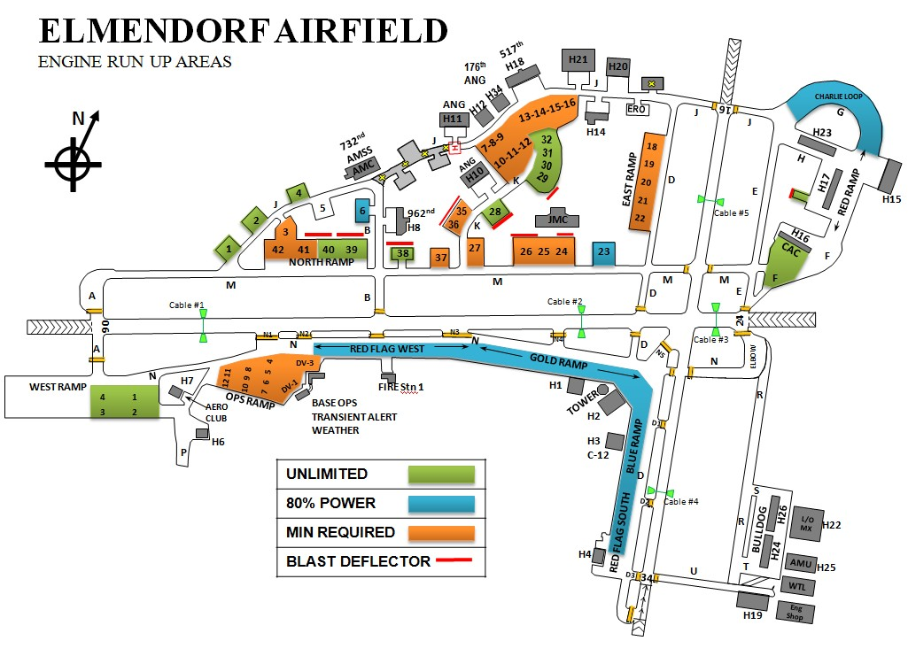

  - Transient Aircrew. Coordinate run-up locations and power settings with AM, Tower, or transient alert (TA).

- Drag Chute Jettison Procedures. Under normal circumstances, chutes will not be dropped on the runway. Pilots dropping chutes will notify the Tower of the drop location. The Tower will forward the information to AM for recovery.

- Hot Pit Refueling Areas. West Ramp Spots 1 through 4 are designated as hot pit refueling areas. Hardstands 18-22 (East Ramp) are also designated hot pit refueling areas. Use of hot pit refueling areas requires prior coordination with the 732 AMS, AM and 3 OSS Scheduling.

- Aircraft Towing Procedures. Aircraft tow operations will be accomplished in accordance with AFI 11-218 and 3 WGI 13-213, Airfield Driving Program.

  - Limited Visibility Towing Procedures. These procedures will be conducted in accordance with 673 ABW OPLAN 32-1002, Snow and Ice Control Plan. These procedures will be placed in effect when degraded visibility may affect safety between aircraft and snow removal operations. Maintenance operations center (MOC) will notify AM of tow routes. Tower will notify the Snow Removal Supervisor of all pending aircraft ground movement operations. Tower will also notify the Snow Removal Supervisor and AM of active tows and taxiing aircraft to include the aircraft’s point of origin, destination and routing when limited visibility procedures are in effect. Aircraft tows within a flying squadron’s designated parking ramp (restricted area) during limited visibility must be approved by Tower.

  - Aircraft Tow Procedures. MOC (3 WG MOC/AMC MOC/176 WG MOC) will notify Tower and the Base Defense Operations Center of pending tow operations on the airfield, stating the type aircraft, tail number, starting point, and destination. The Tow Team Supervisor will ensure radio contact, via aircraft radios, is established with Ground Control prior to aircraft tow. During limited visibility towing, Tow Team Supervisors will ensure adequate beacon lighting outlines both the vehicle and aircraft. The Brake Operator will establish radio contact with Ground Control and state the tail number, starting point, destination, and route to be followed. For power- off tows, the Tow Team Supervisor will make radio contact via land mobile radio (LMR) to request tow approval. Aircraft will not be towed across both runways via Taxiway E to N-5 (the diagonal). NOTE: When 176 WG MOC is closed/not operational, request for aircraft tow will be via aircraft radio to Ground Control. Aircraft tows will not enter any designated taxiway without Ground Control approval and tow vehicles must maintain radio contact once approved onto a taxiway. Tows within a designated parking ramp must monitor Ground Control in case of unforeseen circumstances.

- Aircraft Taxiing Requirements. All locally assigned aircraft will adhere to the taxi instructions below. All taxiing aircraft are responsible for de-confliction into and out of parking areas.

  - Aircraft will not taxi on runways, taxiways or ramps without two-way radio communications and approval from Tower. Aero Club aircraft may silent taxi on Taxiway P. Contact will be made with Ground Control prior to taxiing on Taxiway N.

  - Anti-hijack measures (Paragraph 70, this instruction) will be activated if any aircraft, other than those listed above, is observed taxiing without Tower approval.

- Airfield Maintenance. Airfield maintenance crews will coordinate with AM before any work will be conducted on the airfield. Work crews will properly mark works zones and ensure a sweeper is in the area prior to starting and during construction operations to mitigate a potential foreign object damage (FOD) hazard to aircraft operations.

22

  - Airfield Mowing Operations. Airfield Mowing will be in accordance with 3WGI 91-212, Bird and Wildlife Aircraft Strike Hazard (BASH) Program, and AFPAM 91-212, Bird and Wildlife Aircraft Strike Hazard (BASH) Management Techniques. Grass should be mowed by 30 June and 31 August yearly, or as needed to remain between 7-14 inches. AM will be notified two days prior to commencement of mower activity on the airfield. AM will issue appropriate NOTAMs and notify all agencies prior to mowing operations on the airfield.

  - Airfield Sweeper Operations. Airfield sweeping will be accomplished in accordance with 3WGI 32-1004, Elmendorf Airdrome Sweeping.

Runway Surface Condition (RSC)/Runway Condition Reading (RCR) Values:

  - RCR Equivalent values to braking action:

21.1.1. 02 – 05 = NIL.

21.1.2. 06 – 12 = POOR.

21.1.3. 13 – 18 = FAIR.

21.1.4. 19 – 25 = GOOD.

  - RSC Abbreviations:

    - WR – Wet Runway.

    - IR – Ice on Runway.

    - SLR – Slush on Runway.

    - PSR – Packed Snow on Runway.

    - LSR – Loose Snow on Runway.

    - /P – Patchy.

- Procedures/Requirements for conducting Runway Inspections/Checks. AM will perform a comprehensive airfield inspection at the beginning of each duty shift and multiple periodic airfield checks throughout the course of the day. The SOF and 3 WG Flight Safety will also conduct periodic airfield checks. AM is the only agency that can give the official airfield status report. Agencies that suspect a safety hazard, such as FOD or poor runway surface conditions, will request AM assistance.

Noise Abatement/Base Quiet Hour Procedures:

  - Aircraft will avoid over flying the base hospital and South of Runway 06 for noise abatement and safety reasons.

  - Base quiet hours are from 2230 - 0600 local, Monday through Friday, and 2230 – 0800 local on Saturday, Sunday, and holidays. Full stop landings and departures are authorized during base quiet hours. Exceptions will be coordinated by the 673d ABW Command Post (673 ABW/CP) and must be approved by the 3 OG/CC, 3 MXG/CC, or 732 AMS/CC, as appropriate. Approvals will be forwarded by 673 ABW/CP to the MOC, AM and the Tower.

Exceptions to Base Quiet Hours:

    - The 517 AS/249 AS C-17s and 176 WG C-130/HH-60s may conduct multiple approaches to Runway 06, Runway 16 and Runway 34. Limit the use of thrust/propeller reversing, to the maximum extent possible.

    - Aero Club may conduct Runway 06/24 takeoffs and landings with patterns flown to the North side of the runway.

    - The 3 WG MOC will be the coordination agency for approval/disapproval and engine run requirements during base quiet hours. The 3 WG/176 WG aircraft requiring idle engine runs may be run during base quiet hours.

      - Fighter aircraft requiring high power runs will be run only in the test cell facility. The test cell facility is authorized to perform installed/uninstalled engine runs at any power settings during quiet hours.

      - Heavy aircraft North of Runway 06/24 may conduct high power/reverse thrust runs during base quiet hours. Heavy aircraft South of Runway 06/24 and not on alert status will standby until quiet hours expire. Heavy aircraft South of Runway 06/24 and on alert status require 3 MXG/ CC approval for high power/reverse thrust runs during base quiet hours. The 3 WG MOC will notify Tower and AM of 3 MXG/CC approval for engine runs during published base quiet hours.

      - All visiting units that require engine runs during base quiet hours will coordinate through the 3 WG MOC for 3 MXG/CC approval. The 3 WG MOC will notify Tower and AM of 3 MXG/CC approval for engine runs during published base quiet hours.

Ceremonial Quiet Hour Requests (Attachment 2):

24

    - Submit requests to implement ceremonial quiet hours to Operations Scheduling (3 OSS/ OSOS) at least 2 weeks in advance for inclusion in the wing and AMC flying schedules. Requests must include the purpose of the event, location, event start/finish times, and noise reduction measure requested. Measures will be in accordance with one of the following options:

    - Option 1. Airfield Closed (Requires 3 OG/CC Approval). The airfield will be NOTAM closed to arrivals, departures, practice approaches, aircraft movement, engine starts, engine runs, and aerospace ground equipment (AGE) operations will be terminated. Vehicle traffic adjacent to the event hangar will be terminated.

    - Option 2. Restricted Operations (Requires 3 OSS/CC Approval). Only straight-in full stop arrivals will be authorized. Arriving aircraft may taxi to park provided they do not pass in close proximity to the event hangar. Alternate taxi and parking locations may need to be coordinated with AM. Departures, engine starts, engine runs, practice approaches, and AGE operations will be terminated. Vehicle traffic adjacent to the event hangar will be terminated.

    - Option 3. JBER-Richardson Side Ceremonies (Requires 3 OSS/DO Approval). If possible, departures will be delayed for a 30-minute period for the ceremony, unless Runway 24 is used. Arrivals will be Runway 06 straight-ins to a full stop, unless operational necessity dictates otherwise. An advisory to avoid over-flight of the Bryant Segment will be placed on the Elmendorf ATIS.

Option 4. Selected Measures (Requires 3 OSS/CC Approval Based on Measures).
Closures and/or restrictions will be customized from the above options.

    - Upon approval but no earlier than 7 days prior to the event, 3 OSS/OSOS will pass quiet hours to AM. AM will issue a NOTAM or airfield advisory.

23.5. Base Flying Hours. Base assigned aircraft will conduct normal flying hour operations during the times not restricted by paragraph 23.2 of this instruction. If normal day-to-day 3d Wing fighter flying will exceed a 12 hour fly window, Wing Scheduling will contact 3 OSS/OSA to ensure there is adequate ATC manning available to support the flying mission. To the maximum extent possible, ATC manning will consist of a Watch Supervisor and all positions staffed and
de-combined during designated wing/base flying hours. Exceptions will be briefed to the AOF/CC. ATC is manned for AMC and transient aircraft operations 24/7 by a single 7-level Watch Supervisor during mid-shifts.

- Restricted/Classified Areas on the Airfield. The red lines on aircraft parking ramps indicate restricted areas. These areas are considered active when aircraft are parked within the confines of the marked restricted area. Entry into restricted/classified areas is only authorized via designated entry control points (ECP). The restricted area surrounding the 962 AACS hangar, Hardstand 38, and the CAC are classified areas and access is restricted at all times.

  - Red Line Clearance/Free Zone Waiver. Agencies (that is, painters, airfield sweepers, and so forth) which require permission to cross restricted area red lines in order to perform their mission will coordinate with Security Forces prior to commencing operations for “Red Line Clearance.” AM will coordinate with Security Forces for permission for contractors requiring a Free Construction Zone.

    - Non-Winter Red Line Clearance Operations. Agencies requiring red line clearance will coordinate with Security Forces on a real-time basis. Security Forces will need to know the number of vehicles, number of individuals, agency affiliation, location on the airfield, and time requirements before they will issue a red line clearance. Agencies requesting extended periods (that is, construction) of red line clearance will coordinate with AM to obtain a Free Construction Zone.

    - Winter Red Line Clearance Operations. Due to the inability to observe red lines during the snow season, vehicle access to aircraft parking areas should be limited to mission essential vehicles only. AM and 773 CES (Road and Grounds) require normal day-to-day access to aircraft parking ramp areas to conduct snow removal and pavement friction reading measurements.

- Procedures for Suspending Runway Operations. AM or Tower may suspend runway operations. Common reasons for suspension of operations include: immediately following an emergency aircraft landing, snow removal operations, BAK-12 system resets, unsafe surface conditions, safety checks of the runway by AM personnel. Only AM personnel can resume runway operations.

- Procedures for Opening/Closing the Runway. AM is the only agency that can open or close a runway.

26

Protection Precision Approach Critical Areas:

Figure 27.1. Instrument Landing System (ILS) and PAR Critical Areas.
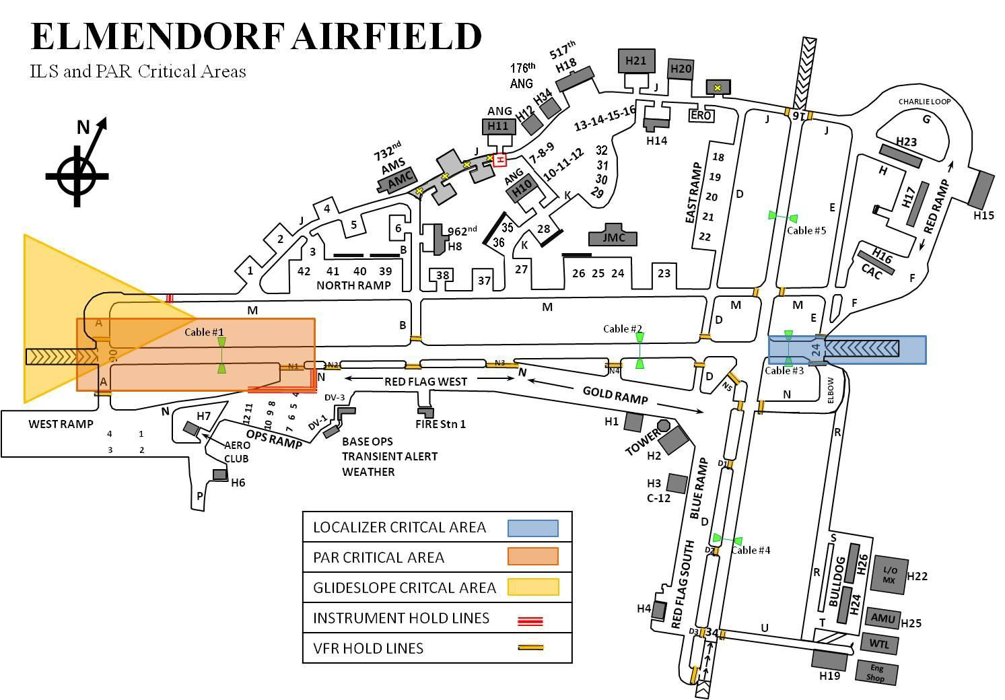

  - Localizer Critical Area. This rectangular area extends from the localizer transmitting antenna 2,000’ toward the approach end of Runway 24 and 200’ on each side of the runway centerline. It includes a 50’ extension behind the localizer antenna. The visual flight rules (VFR) runway hold lines and the instrument hold lines are coincidental; therefore, only the VFR runway hold lines are depicted at these locations.

  - Glideslope Critical Area. This is a fan-shaped area that extends from the glide slope antenna 1,300’ toward the approach end of Runway 06. It covers an area 30 degrees each side of a line drawn through the glideslope antenna and parallel to the runway centerline. Instrument hold lines for the glideslope critical area are located on Taxiway M and Taxiway Alpha South.

  - PAR Touchdown Zone Critical Area. This is a 3,200 foot long by 1,000 foot wide rectangle centered on the runway centerline at the approach end of Runway 06. It begins 200’ prior to the landing threshold and extends 3,200’ in the direction of landing. Instrument hold lines for the PAR critical area are located on Taxiway N, West of Taxiway N2, along the intersection of Taxiway N and the Ops Ramp.

  - Criteria outlined in AFI 13-204, V3, Functional Management of Airfield Operations, and FAAO 7110.65 will be used to protect the precision approach critical areas identified above.

Civil Aircraft Operations:

  - AM is the designated representative for processing civil aircraft landing permits in accordance with AFI 10-1001, Civil Aircraft Landing Permits. AM will coordinate with the 3 WG/CC on required actions for Elmendorf.

  - AM will process civil landing permit requests for privately owned aircraft operations at Elmendorf Airfield.

  - Civil aircraft can only operate with an approved landing permit and for the approved “purpose of use,” in accordance with AFI 10-1001.

  - All operations not in accordance with AFI 10-1001 will be designated as an unauthorized landing and will be processed accordingly.

  - Aircraft owners are responsible for maintaining the appropriate paperwork on privately owned aircraft and ensuring renewal approval occurs prior to expiration.

  - Tower will notify AM as soon as possible of civil diverts in to Elmendorf. AM will park the aircraft on West Ramp Spots 1-4, the JMC Ramp or coordinate with AMCC for other parking areas. All aircraft with wing span less than or equal to 140’ will be parked on Ops Ramp.

  - AM will notify Security Forces of all civil aircraft diverts.

- Civil Aircraft Practice Approaches. Civil aircraft may execute practice approaches with Tower approval but are subject to the following restrictions:

  - Altitude Deviation: Approval of an altitude deviation indicates that an aircraft may enter Elmendorf’s Class D segment at any altitude within the segment and allows aircraft to use either an 800’ MSL or 1200’ MSL traffic pattern altitude in preparation for landing unless specifically directed otherwise by ATC.

  - Practice approaches will not be approved for civil aircraft during Base Quiet Hours (2230 to 0600 local time). Exceptions to this policy are outlined in paragraph 22.3.2, this instruction.

  - Civil aircraft, other than base assigned, are prohibited from conducting touch and go, stop and go or full stop landings, except for emergencies or as authorized by AM.

28

- Civil Use of Military NAVAIDS/ATCALS. There are no NAVAIDS on Elmendorf Airfield that are part of the National Airspace System. Civil Aircraft use the ILS and distance measuring equipment (DME) on approach to Elmendorf/Merrill and AM will ensure appropriate NOTAMs are published when these NAVAIDS are unavailable.

Aero Club Aircraft Operations:

  - Aero Club flight plans may be filed in person or faxed to AM. Faxed flight plans will be followed up with a telephone call to ensure receipt and accuracy. Aero Club will maintain the original flight plan, crew list, manifest, fuel load, weight and balance information, and other pertinent information on faxed flight plans in accordance with Air Force WEB-RIMS Records Disposition Schedule (RDS) located at https://www.my.af.mil/afrims/afrims/afrims/rims.cfm.

  - Aero Club aircraft may silent taxi on Taxiway P, but must contact Ground Control prior to taxiing on Taxiway N.

  - Aero Club may conduct Runway 06/24 departures and landings with patterns flown to the North side of the runway during Base Quiet Hours. This authorization does not apply to Ceremonial Quiet Hours.

  - Reduced Same Runway Separation does not apply to aero club aircraft (paragraph 43, this instruction).

  - Aero Club aircraft will use VFR departure procedures outlined in paragraph 39, this instruction.

  - VFR Aero Club aircraft that lose communications while outside Elmendorf’s Class D airspace should proceed to the nearest uncontrolled airport (normally Birchwood Airfield) and land immediately.

  - VFR Aero Club aircraft that lose communications while inside Elmendorf’s Class D airspace will proceed to the Antenna Farm and hold at 800’ MSL, awaiting a steady green light from
Tower. Upon receipt of a steady green light from Tower, the aircraft may proceed inbound and land on any runway. NOTE: Pilots of aircraft with lost communications should continue to transmit their intentions and pattern positions on appropriate frequencies.

Section B--Flying Areas

- VFR Local Training Areas. There are no VFR training areas in Elmendorf’s Class D airspace. The following points are local VFR reporting points. Point No-Name, Cujac, Kulis, Blink, 381st Intelligence Squadron Antenna Farm, Hillberg Ski Slope, Six-Mile Lake, Otter Lake, Bryant Army Airfield (AAF), JBER Hospital and the Muldoon Intersection.

Figure 32.1. Points of Interest.

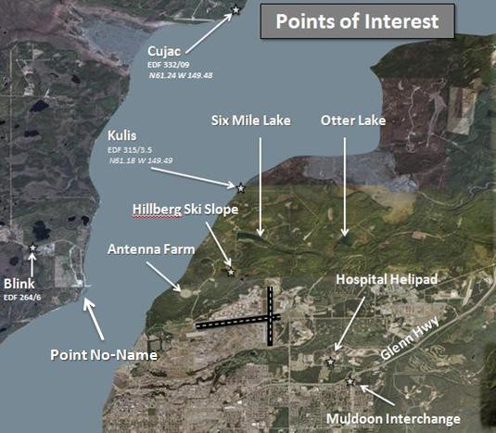

- Local Flying Area/Designation of Airspace. Elmendorf Class D segment. That area from the surface up to but not including 3,000’ MSL, within a line beginning at Point No-Name; thence via the north bank of Knik Arm to the intersection of the 4.7-mile radius of Elmendorf Airfield; thence clockwise along the 4.7-mile radius of Elmendorf Airfield to longitude 149° 46' 44"W.; thence south along longitude 149° 46' 44"W. to latitude 61° 19' 10"N.; thence to latitude 61° 17' 58"N., longitude 149° 44' 08"W.; thence to latitude 61° 17' 30"N., longitude 149° 43' 08"W.; thence south along longitude 149° 43' 08"W. to the Glenn Highway; thence south and west along the Glenn Highway to Muldoon Road; thence direct to the mouth of Ship Creek; thence direct to the point of beginning.

30

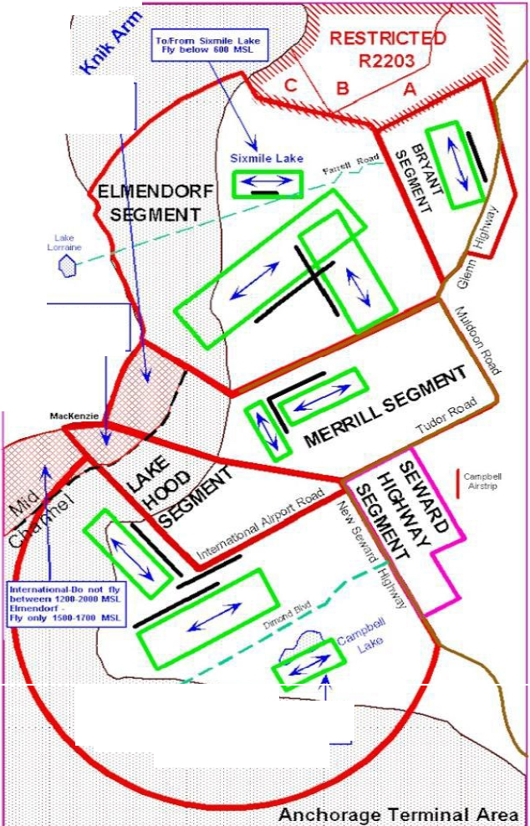
Figure 33.1. Local Airspace.93

Menifl - Oo not fly Detween 68'-2000 I.ISL Elmendorf
Fly only 908 -1701MSl

Lo "llood - Do not fly between 12012000 MSL Bmendoff -
f ry only 1$90-1700 MSL

Pt.

INTERf>LA110NA L
: ME Tlo-from Cim_P_l>_elt L•ke
/ ,:. ,. fly below 601!.1SL
::: . :.
·::- ·:
:::: .·. - . -.

Figure 33.2. Part 93 Airspace.
14 CFR Part 93 AIRSPACE

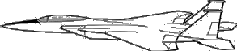

ERRILL

LAKE HOOD

2000’

1600’
1200’
3000’
ELMENDORF
M
ANCHORAGE
MERRILL
TRAFFIC DO NOT FLY BETWEEN 600’ AND 2000’
2000’
2000’
ANCHORAGE
AND LAKE HOOD TRAFFIC DO NOT FLY BETWEEN 1200’ AND 2000’
1500 – 1700 ONLY
1200’
600’

33.1 Six Mile Transition. In accordance with a published exemption to Federal Aviation Regulation (FAR) 93, Special Air Traffic Rules and Airport Traffic patterns, requirements, a person operating in VFR conditions at/below 600’ MSL, North of a line beginning at the intersection of
Farrell Road and the long. 149o43’08”W; thence West along Farrell Road to the East end of Six
Mile Lake; thence West along a line bearing on the middle of Lake Lorraine to the North West bank of the Knick Arm; is not required to establish two-way radio communication with ATC.

Section C. VFR Procedures

- VFR Weather Minima: Weather should allow use of visual entry/reentry point for the respective runway in use. The Tower Watch Supervisor has the discretion of closing all or a portion of the VFR traffic pattern when weather minimums are met but weather phenomena such as clouds or fog prevent tower personnel from visually acquiring aircraft in the traffic pattern. Note: METARs report cloud height in AGL, mins below are also AGL altitudes.

  - Raptor to Tactical Initial: (See BRODE/CRUZR LoA)
  - Cujac to Tactical Initial: (See BRODE/CRUZR LoA)
  - Re-Entry/Break-out: 2500’ / 3 SM
  - Overhead/ILS transition to initial: 2000’/ 3 SM
  - Rectangular: 1500’/ 3 SM
  - Light Civil: 1100’ / 3 SM

32

Figure 35.1
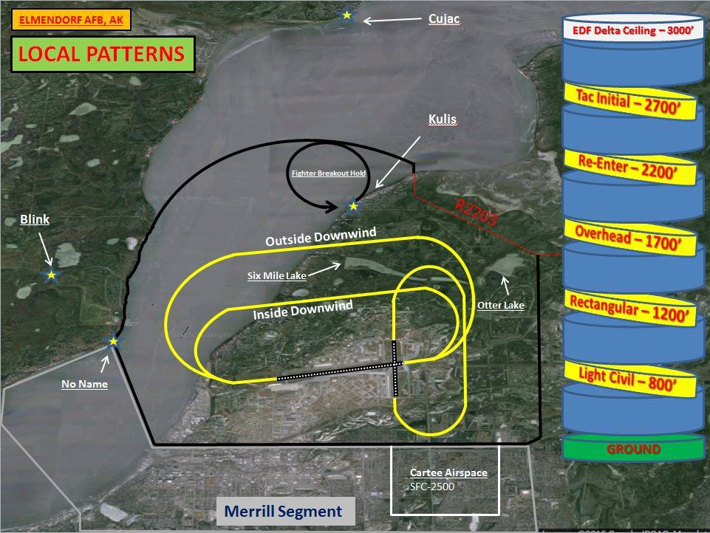

- VFR Pattern Altitudes/Procedures: All patterns to Runway 06 or Runway 16 will be left turns, all turns for patterns to Runway 34 or Runway 24 will be right turns. Note: Any approach to runway 34 should include the status of the Cartee Airspace relayed to the pilot from ATC. Controllers shall relay once Cartee is available or revoked. (I.E. “Callsign, Tac-initial to Rwy 34 approved, Cartee available” Additionally, pilots over-flying the Six-Mile Lake area should be alert for aircraft operating below 600’ MSL. This area is not visible from the Elmendorf Control Tower. Six Mile Lake Sportsman Club pilots have been approved to conduct operations at or below 600’ MSL without radio contact with Elmendorf Tower. Additionally: High performance aircraft are prohibited from over-flying the JBER Hospital.

35.1 Overhead Pattern: 1700' MSL to join the inside downwind ground track depicted on figure
  - NOTE: Descending break to 1200' MSL for non-fighters available with tower approval.

    - Initial (Runways 06/16/34): Downwind for all three runways is entered from the point of initial 1NM to 2NM from the approach end of Runway 06. Aircraft will overfly Runway 06 at 1700’ MSL, and then break to enter the inside downwind of Runway 06, 16, or 34.

    - Initial (Runway 24): Due to airspace constraints to runway 24 with Bryant Field, there is not an entry procedure to fly the overhead to runway 24 besides the “High-initial”, “Tac-initial”, or “Right turn back to initial” as described later in this chapter.

    - Overhead Protection: To provide separation from the overhead pattern during VMC, pilots executing other than full stop landings on Runway 06/24 and Runway 16/34 will remain at or below 1,200’ MSL until the departure end of the runway, unless the Tower approves a deviation.

    - “Left-Turn to Initial”: (Runway 06/16/24 only) When flying on inside downwind, fighters only may be directed to make a left turn back to initial. If directed to execute a left turn back to initial, pilots will maintain 1,700’ MSL and execute a left turn at the approach end of the runway to proceed back to initial. Note: For all above mentions of a “Left Turn”, a “Right Turn” will be used for Runway 24 operations. Due to airspace restrictions, a right turn to Runway 34 cannot be used.

  - Rectangular/Inside Downwind: 1700’MSL-Fighters/ 1200’MSL-Non-fighters/ 800’ MSL Light civil aircraft. Pilots will fly standard traffic patterns and will not initiate a crosswind turn until the departure end of the runway, unless the Tower approves or directs a deviation. Extended downwind legs require Tower approval.

Tactical Initial.

    - Runway 06/16/34: Aircraft will fly the RAPTR or CUJAC Transitions (See specific weather requirements for each transition in the A11/ZAN/3OG Brode/Cruzer LOA.) Prior to reaching 10 Distance Measuring Equipment (DME), pilots will request tactical initial to a specific runway with Anchorage Approach. Aircraft will cross mid-channel at 3500’MSL, then descend to 2700’ MSL at “feet dry.” Then proceed to the Runway 06 and Runway 34 intersection at 2700’ MSL and execute a descending turn to 1,700’ MSL to enter the downwind for the appropriate runway, unless otherwise directed by Tower. (See image 35.2 for Runway 06/16/34 Tactical Initial)

    - Runway 24: Aircraft will fly VFR direct to KULIS descending to 2,700’ MSL mid- channel. From KULIS, aircraft will fly between Six Mile Lake and Otter Lake, report initial for Runway 24 and break midfield to enter a right downwind pattern for Runway 24 while descending from 2700’ MSL to 1,700’ MSL, unless otherwise directed by Tower. Runway 34 departures are prohibited when aircraft are recovering to Runway 24 Tac-Initial. See figure 35.3 below.

    - RAPTOR and CUJAC Transitions: The RAPTOR and CUJAC transitions are IFR recoveries that proceed VFR from Blink and transition to either tactical initial or initial as outlined in the A11/ZAN/3 OG CRUZR and BRODE LOA.

Figure35.2
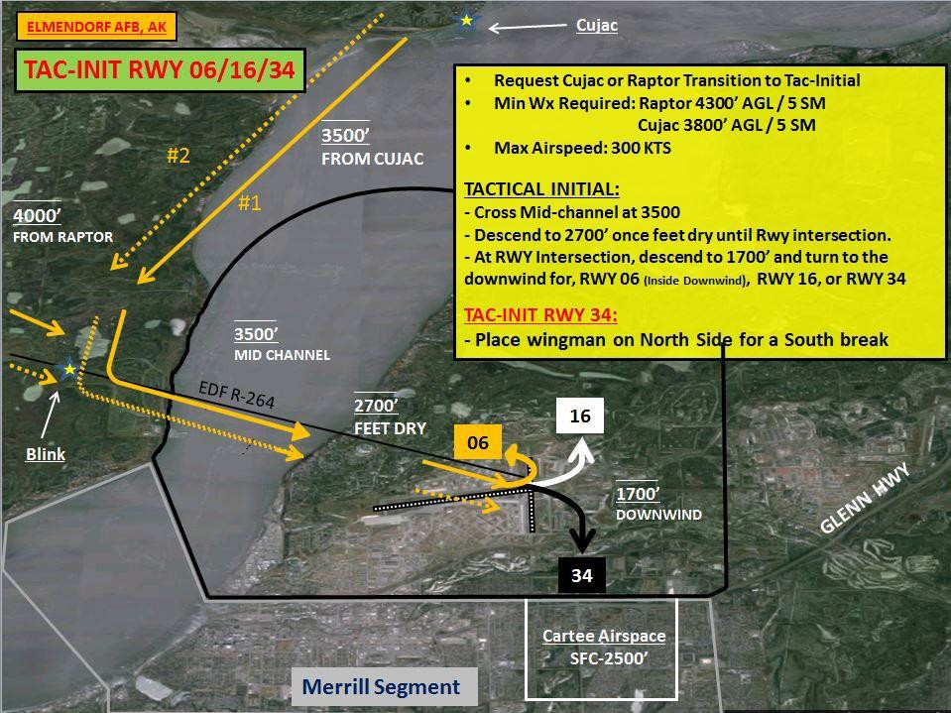
34

Figure 35.3
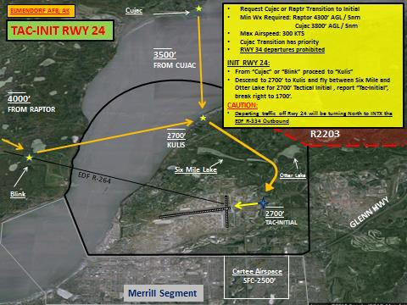

  - VFR Straight-in (Runway 06/16 only.): Altitude for a VFR straight-in approach is 1,200’ MSL on a 2 NM final. Approval for a VFR straight-in will be issued from either the outside downwind or Kulis.

  - Go-Around: Aircraft instructed “(Call sign), GO AROUND, (Reason, time permitting)” after turn to final has been started will complete the final turn, then should fly parallel to, but not overfly the runway on the maneuvering (traffic pattern) side and will maintain at or below 1,200’ MSL until departure end.

  - VFR Breakouts: VFR Breakout procedures will be used only for traffic conflicts, emergencies, or landing gear problems and are not to be confused with reentry procedures.

    - Rwy 06/24: Pilots will remain VFR, maintain altitude, and turn away from the traffic pattern toward Kulis. Once at Kulis, aircraft will hold in left hand turns remaining feet wet, and climb to 2200’ MSL, remaining clear of R-2203, and will contact Tower for re-entry instructions and traffic advisories.

    - Rwy 34: Pilots will remain VFR, maintain altitude, and turn away from the traffic pattern. Proceed northbound and cross Otter Lake at 2200’ MSL. Report Otter Lake for Tower re-entry instructions, if no instructions received, proceed to Kulis. Once at Kulis, aircraft will hold in left hand turns remaining feet wet, and maintain 2200’ MSL, remaining clear of R-2203, and will contact Tower for re-entry instructions and traffic advisories.

C-17/C-130 VFR Traffic Patterns

    - Troy 1 Recovery: The Troy 1 Recovery is a VFR recovery procedure that ends in an overhead and is flown at 1,700’ MSL via the ground track depicted in the A11/176OG/3OG Local aircraft operations LOA. Aircraft will contact Anchorage Approach Control prior to entering the Anchorage Class C Segment and request the “Troy 1 Recovery.”

    - CUJAC Transition to the Overhead: This procedure is flown from the CUJAC Transition. Aircraft will cross BLINK at 3,500’ MSL and will request to enter the overhead pattern to Runway 06 or downwind patterns to Runway 16, 24 or 34. Phraseology for this request will be: “CALL-SIGN, REQUEST CUJAC HIGH, OVERHEAD/DOWNWIND TO RUNWAY XX.”

    - KULIS Transition: C-130s and C-17s may request to enter the VFR pattern via the KULIS Transition. Aircraft will cross CUJAC, descend to 2,000’ MSL and proceed VFR direct KULIS.

      - KULIS Transition Straight-In Runway 16: After passing KULIS, aircraft will descend to 1,200’ MSL, unless otherwise directed by Tower, and execute a straight-in Approach to Runway
16. Aircraft will use the following phraseology for this request: “CALL SIGN, REQUEST KULIS TRANSITION STRAIGHT-IN RUNWAY 16.

      - KULIS Transition to Shallow Abeam: The Kulis Shallow maneuver will be flown at or above 700’ MSL (500’ AGL). Aircraft will cross KULIS at 2,000’ MSL and execute a descent to maintain at or above 700’ MSL (500’ AGL), unless otherwise directed by Tower. Aircraft will request to proceed to the Runway 16/34 and Runway 06/24 intersection for a left/right turn to Runway 16, Runway 06 or Runway 34. Phraseology for this request will be: “CALL-SIGN, REQUEST KULIS TRANSITION SHALLOW ABEAM RUNWAY XX”. NOTE: When below 800’ MSL, aircraft inbound for these approaches should broadcast position and intentions on Six Mile Lake Common Traffic Advisory Frequency (CTAF) 122.8. (NOTE: Shallow Abeams may only be authorized with a sterile pattern due to safety concerns with other traffic.)

      - KULIS Transition to Downwind: After crossing KULIS, aircraft will descend to 1,200’ MSL, unless otherwise directed by Tower, and request to enter a downwind pattern for Runway 06, Runway 34 or Runway 24. Phraseology for this request will be: “CALL-SIGN, REQUEST KULIS TRANSITION TO DOWNWIND RUNWAY XX.”

      - KULIS Transition to the Overhead: Aircraft will cross KULIS and execute a descent to 1,700’ MSL, unless otherwise directed by Tower, and will request to enter Initial to Runway 16, Runway 06 or Runway 24. Phraseology for this request will be: “CALL-SIGN, REQUEST KULIS TRANSITION OVERHEAD RUNWAY XX.”

    - Mid-channel Transition: The Mid-Channel Shallow maneuver will be flown at or above 700’ MSL (500’ AGL). Aircraft will cross mid-channel (between Blink and Kulis) at 2,000’ MSL intercepting the EDF R-267 and execute a descent to maintain at or above 700’ MSL (500’ AGL), unless otherwise directed by Tower. Aircraft will request to proceed to the Runway 06/34 intersection for a left/right turn to Runway 16, Runway 06 or Runway 34. Phraseology for this request will be: “CALL-SIGN, REQUEST MID-CHANNEL TRANSITION, RUNWAY XX”. NOTE: When below 800’ MSL, aircraft inbound for these approaches should broadcast position and intentions on Six Mile Lake Common Traffic Advisory Frequency (CTAF) 122.8. (NOTE:
Shallow Abeams/Mid-channel transitions may only be authorized with a sterile pattern due to safety concerns with other traffic.)

36

    - Random Steep Approach: A VFR maneuver allowing base assigned C-130/C-17 pilots to practice approaches and landings in a simulated hostile environment. This maneuver is subject to tower approval and consists of a high altitude, steep spiral, and descent over the airport to the RWY/AZ. Procedures are as follows:

      - The random steep maneuver requires coordination with Anchorage Approach if performed above 3,000' MSL. Standard procedure will be a left break, one turn to final, and only flown to RWY 16 unless otherwise approved by ATC. (NOTE: Typical requested altitude is 8000'MSL)

      - Aircrews should: Request coordination with Anchorage Approach or Elmendorf Tower at least 15 minutes in advance for approval and sequencing. Perform random steep maneuvers up to the coordinated altitude while remaining in the lateral confines of the Elmendorf Class Delta.

    - Assault Landing Zone (ALZ) Operations: Aircrew will, to the maximum extent possible, contact Tower at least 15 minutes prior to the requested ALZ operations to allow time for re- sequencing of existing or known traffic. Aircrew must advise Tower if planning to depart Runway 34 after landing Runway 16 as soon as possible to allow time for sequencing of other traffic. Note: Engine-Running On/Off/Combat loads must be prior coordinated with AM. The normal location for these activities will be taxiway Delta between Juliet and Mike or on the East Ramp. Secondary desired location is Taxiway Mike in front of the JMC. All other areas will be determined on a case by case basis.

      - ALZ aircrew/planners will accomplish prior coordination with airfield operations for approval to use temporary ALZ lights on Runway 06. Upon notification and issuance of approval, AMOP will notify Airfield Lighting and the Tower of the proposed time for setup and use of the temporary ALZ lighting on Runway 06. AM will publish the following NOTAM: “Runway 06/24 Lights will be turned off for NVG/infrared (IR) operations, contact TWR 15 minutes prior for normal lighting operations, Valid from XX Jan 2012, 0400Z – XX Jan 2012, 0500Z.”

      - Prior to departing, the applicable aircraft will request taxi onto the active runway. Once on the runway, a crew member will exit the aircraft and install 4 to 6 temporary ALZ lights over the existing runway edge lights. The aircraft will then depart to conduct practice ALZ approaches. The temporary ALZ lights are IR and will require that the runway edge lights be turned off during practice approach operations. When non-participating ALZ aircraft are inbound and/or preparing for departure, Tower will instruct the practice aircraft to cease operations and will turn all associated runway lighting back on for the inbound/departing aircraft. Upon completion, the practice aircraft will land and stop on the runway to allow a crew member to exit the aircraft and remove the temporary lighting. Tower will notify AMOPs when the ALZ aircraft has finished their training for the evening and will suspend runway operations for completion of a FOD check by AMOPs after which runway operations will be resumed and the NOTAM will be removed.

- VFR Entry Procedures: If radar service is not used/available, pilots will contact Tower with the ATIS code prior to entering the Elmendorf Class D airspace and state intentions. Unless otherwise advised by the Tower, pilots not on a published arrival procedure will enter Elmendorf’s Class D airspace through Kulis at traffic pattern altitude and fly a 45-degree entry leg to downwind or enter via initial.

  - ILS Ground Track: (Min Wx 2000’ AGL /3 SM) Fly the published ILS approach until VMC and cleared for initial. Upon cancellation of IFR continue w/ILS ground track and maintain 1500' - 1700' MSL IAW FAR Part 93 until mid-channel. If not VMC by the FAF, inform the controller and continue the ILS. Do not transition to the overhead inside the FAF. Rwy 34: Fly Initial to Rwy 6...break to downwind Rwy 34. Execute normal base turn to land.

- Fighter Re-entry: Re-entry is used to bring fighters back to “High Initial” at 2200’via the outside downwind. The radio call for re-entries is “(Call sign), RE-ENTER”. See Figure 37.1 and 37.2.

    - From Initial: When directed to, or when requesting to re-enter, aircraft will fly straight through initial, maintain 1700’ MSL until the departure end of the runway, and fly the outside downwind at 2200’ MSL.

    - From Low Approach/Touch-and-go: Aircraft on climbout after a low-approach/touch- and-go will maintain at or below 1,200’ MSL until the departure end of the runway and clear of inside downwind traffic. Once past the inside downwind/overhead traffic, and fly the outside downwind at 2200’ MSL.

    - From Tactical Initial: Aircraft will maintain 2700’ MSL until reaching outside downwind and then descend to 2200’ MSL once established on outside downwind.

Figure 37.1
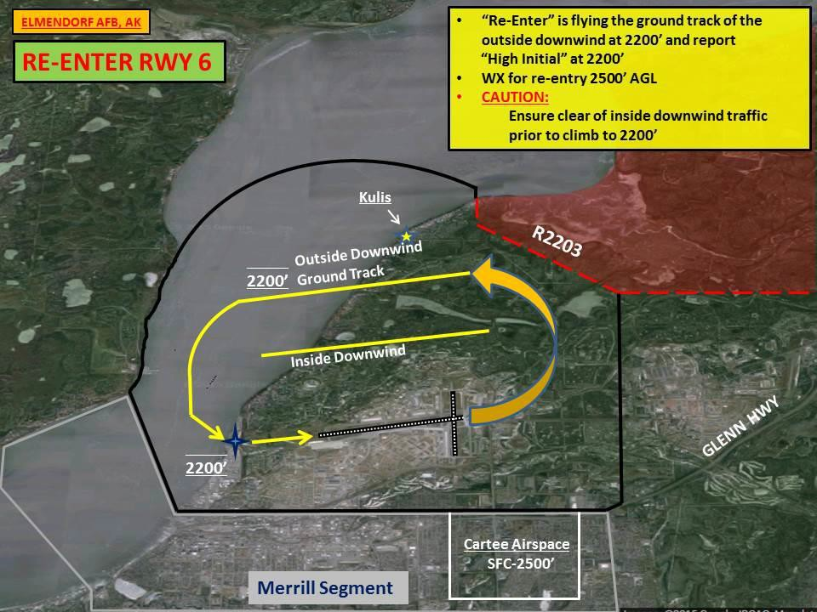

38

Figure 37.2
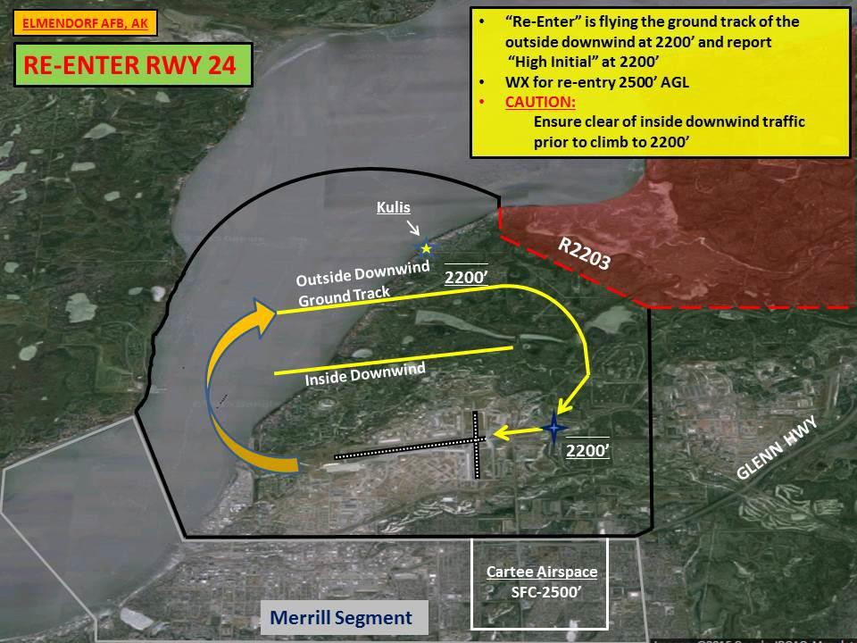

- General VFR Departure Procedures.

  - Ground Control Coordination: VFR aircraft departing Elmendorf will coordinate departure requests, VFR clearance, and taxi instructions with Ground Control. If departing under VFR and requesting radar advisories, contact Ground Control for a beacon code and frequency.

  - Altitude Deviation: Unless authorized by the tower controller, all VFR civilian aircraft are to remain at or below 800’ MSL until outside the EDF class delta. Requests for altitude deviation should be made as soon as possible with Tower for traffic planning purposes. An approval of an altitude deviation indicates that the 800’ MSL altitude restriction on departure is deleted but does not remove the restriction to remain at or below 1200’ MSL until the departure end of the runway.

  - Early Turn Out: The approval of an early turn out indicates that an aircraft may make a turn prior to reaching the departure end of the runway but does not remove the restriction to not over-fly parked or taxiing aircraft.

Elmendorf VFR Departures:

    - Bryant Departure: Proceed direct Bryant AAF.

    - Hospital Departure: Proceed direct to the JBER Hospital (avoid over-flight of the JBER Hospital).

    - Goose Bay Departure: Proceed Northbound to Goose Bay.

    - Six-Mile Lake Departure: Proceed direct to the West end of Six-Mile Lake.

Figure 38.1. General VFR Departures.
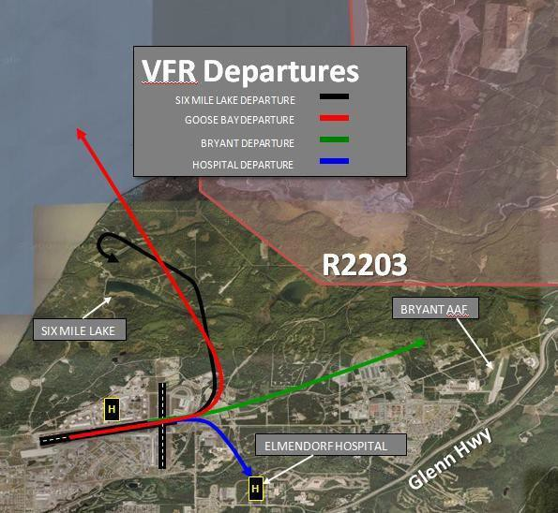

- Opposite Direction Operations: Opposite direction separation applies to all operations IFR or VFR. EDF ATC will enforce separation minima established in the Anchorage (A11)/Elmendorf LOA. When two aircraft will execute approaches to opposite ends of the same runway, or an aircraft will depart prior to an arrival on an opposite direction approach to the same runway. If only one aircraft is involved, it is NOT considered an ODO regardless of the advertised runway in use. IAW FAA guidance, opposite direction operations should only be requested for the following three reasons:

Medevac / Search and Rescue.

  - Operational Necessity: Requests driven by takeoff and landing data, snow or RCR conditions blocking taxi routes, etc. Taxiing late or attempting to join a flight already airborne are not examples of operational necessity.

Emergencies.

- Special Procedures:

  - Fighter Chase Procedures: Chase Formation is a standard formation flown by fighter type aircraft to observe and assist an emergency aircraft or to observe the performance of a pilot in training or on a check ride. All communication to ATC should come from the lead aircraft and include the word “chase”. Both aircraft will never simultaneously full stop in chase formation. The chase aircraft will not take spacing on downwind or final, but will remain with the lead aircraft until one of the following:

    - Full Stop with Chase: The lead aircraft will land, the chase aircraft will execute a go- around after dropping off the lead. No separate clearance is required for the chase aircraft.

Aircraft: CALLSIGN, BASE (or 5-mile FINAL), GEAR, STOP, CHASE.
Controller: CALLSIGN, RUNWAY (number), WIND (surface wind direction and velocity), CLEARED TO LAND WITH CHASE.

40

    - Sequential Closed Traffic from Chase: Aircraft will turn crosswind one at a time to establish downwind spacing. For the purpose of runway separation, aircraft that execute sequential closed traffic remain a flight until completing individual low approaches.

Aircraft: CALLSIGN, REQUEST SEQUENTIAL CLOSED TRAFFIC, (TYPE LANDING.)
Controller: CALLSIGN, SEQUENTIAL (left or right) CLOSED TRAFFIC APPROVED.

  - Unusual Maneuvers: The 3 OG/CC, or designated representative, is responsible for approving unusual maneuvers in Elmendorf Class D Airspace (aerial demonstrations, and so forth.)

  - 16/34 Downwind: Pilots will fly the base leg north of the Glenn Highway to avoid entry into Merrill’s Class D airspace. If flight into the Merrill Class D airspace is required, pilots must ask Elmendorf Tower for the Cartee airspace described below, prior to entering the downwind leg.

  - Cartee Airspace: The Cartee Airspace is a sterile airspace within the MRI Class D Surface Area released to Elmendorf Tower for extended Runway 16/34 operations. Upon release, Elmendorf Tower has approval for control purposes of this area. The Cartee airspace is defined in the current Merrill/EDF ATC LOA and requires a 5 minute advance notice from Elmendorf to Merrill.

Figure 40.1 Cartee Airspace.
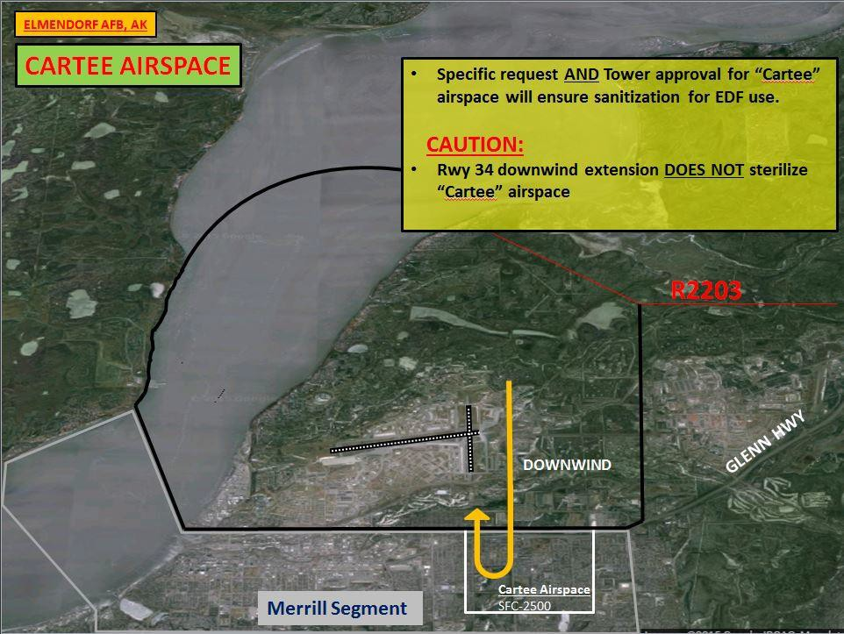

- Helicopter Arrival and Departure Procedures:

  - VFR Helicopter Operations: The 210 Rescue Squadron (RQS) Helicopter operations in and out of the Jolly Pad (Helipad adjacent to Hangar 11) will remain at or below 600’ MSL. Departures and arrivals will proceed via Hillberg and then North or East along via the Six-Mile Transition (to over-fly Goose Bay.) West departures will be via Point No-Name and will avoid the Antenna Farm. South departures will be via a Six-Mile or Hospital Transition (North and East of Runway 16/34 to avoid over-flight of Runway 16/34 and JBER hospital.) Arrivals via an instrument approach may sidestep when VMC to a Hillberg arrival avoiding over-flight of the North side of the base. Low approaches, when VMC, may extend to the runway intersection, and then hook north for a normal arrival into the Jolly Pad. (Depicted in Figure 41.1.) Helicopters should use caution for light civil aircraft operating in the vicinity of Six Mile Lake at or below 600’ MSL.

NOTE: The Jolly Pad is a non-movement area and cannot be seen from the Tower, therefore helicopters will be issued the following instructions when requesting an arrival/departure into/out of the Jolly Pad: “CALL-SIGN, DEPARTURE/ARRIVAL TO/FROM THE JOLLY PAD WILL BE AT YOUR OWN RISK (ADDITIONAL INSTRUCTIONS, AS NECESSARY). USE CAUTION (IF APPLICABLE).”

Figure 41.1. Helicopter Departures/Arrivals.
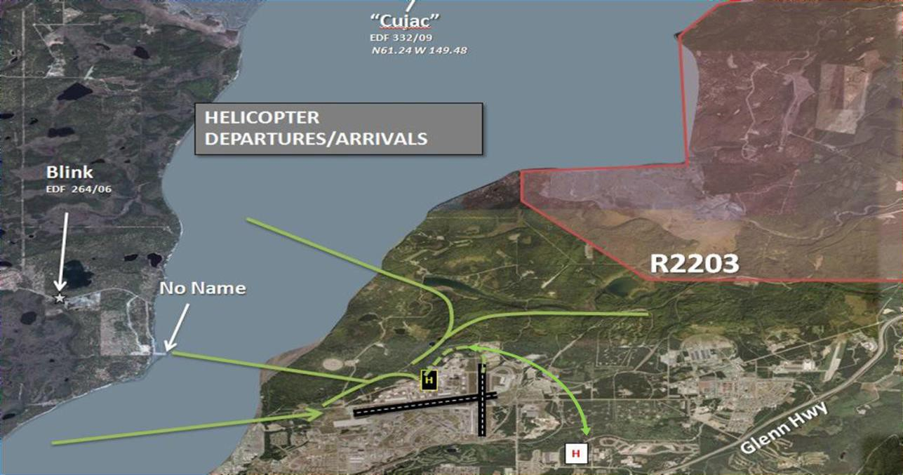

  - Instrument Flight Rule (IFR) Helicopter Operations: To minimize FOD hazard, air taxi operations will be preferred for arrival and departure helicopters transiting between the Jolly Pad and the active IFR runway unless visibility conditions require hover or ground taxi.

Helicopter Training Operations on Runway 34:

    - “JOLLY XX, HELICOPTER OPERATIONS APPROVED ON THE SOUTH HALF OF RUNWAY 34 REMAINING SOUTH OF TWY NOVEMBER, ADVISE WHEN OPERATIONS ARE COMPLETE.”

42

    - “JOLLY XX, HELICOPTER OPERATIONS APPROVED ON THE NORTH HALF OF RUNWAY 34 REMAINING NORTH OF TWY MIKE, ADVISE WHEN OPERATIONS ARE COMPLETE.” NOTE: Operations on the North Half of Runway 34 should be advised of Runway 06 pattern operations. Remaining North of Taxiway Mike does not ensure separation with flights of fighters as one fighter typically offsets. Additional control instructions/altitude restrictions will be issued based upon existing traffic.

Helicopter Hover/Function Checks:

    - Helicopter Functional Hover Checks. Helicopter functional hover checks, with an expected duration greater than two minutes, are authorized for execution on the approach end of Runway 06, the approach end of Runway 16 and/or on the Jolly Pad located in front of Hangar 11.

    - Helicopter Preflight Hover Checks. Helicopter preflight hover checks require helicopters to lift off of the surface by approximately 10 to 20’ for a duration less than 2 minutes. These checks are authorized for execution on the approach end of Runway 06, the approach end of Runway 16, on the Jolly Pad located in front of Hangar 11, or in front of Hangars 1, 10 and 3. Aircrew will coordinate with Tower for execution of these checks and Tower will notify AMOPs prior to authorizing commencement of this procedure and following completion of the check. AMOPs will conduct a FOD sweep of the affected area following completion of this check.

Hospital Helipad Procedures:

  - Pilots using the hospital helipad will contact Elmendorf Tower for advisories prior to takeoff or landing. NOTE: Elmendorf Tower can only issue advisories into/out of the hospital helipad since it is not visible from the Tower.

  - When feasible, pilots are required to advise the Elmendorf Emergency Room at least 1 hour prior to the scheduled use of the helipad. The Emergency Room is the OPR for helipad lighting. When notified of an inbound to the Elmendorf hospital helipad, the Tower will relay the estimated time of arrival and any pertinent information through activation of the primary crash phone to the Emergency Room. Arrivals and departures will enter and exit from South of the helipad to avoid obstructions and over flying the hospital. Time permitting, Tower will delay landings until receiving notification from the emergency room that the helipad is secure/ready for arrival and that the helipad lighting has been turned on.

  - AM will complete a monthly inspection of the hospital helipad.

Reduced Same Runway Separation (RSRS) Procedures:

  - Conditions for application:

    - RSRS may be applied if Air Traffic Controllers are able to see the aircraft involved and determine distances by references to suitable landmarks for daytime and nighttime.

    - Any aircrew or air traffic controller may refuse RSRS when safety of flight may be jeopardized.

    - Revert to nighttime RSRS standards when the RCR is reported to be between 16 and 12 inclusive, or when RCR is not available and RSC is reported as wet, ice or snow.

    - For fighter-type aircraft only: A low-approach following a full stop shall use the alternate side of the runway when passing the aircraft on landing roll. Aircraft will not over-fly aircraft on the runway. Responsibility for separation rests with the pilot. Controllers must provide appropriate traffic advisories to aircraft involved.

    - Controllers will provide cautionary wake turbulence advisories when required in accordance with FAAO 7110.65. Pilots are responsible for wake turbulence separation when maintaining visual separation or operating VFR.

    - Same fighter-type aircraft operations means the same airframe, that is, F-15 behind F-15.

    - Dissimilar fighter-type aircraft operations mean not the same airframe, that is, F-15 behind F-22.

    - Non-heavy, non-fighter type aircraft operations mean C-130, C-12, UC-35, and so forth.

    - RSRS between standard formation full stops are authorized provided all aircraft involved are the same type aircraft. Separation is measured between the trailing aircraft in the lead formation and the lead aircraft in the trailing formation.

  - RSRS does NOT apply to the following:

    - To any situation involving an emergency aircraft.

    - To civil aircraft, including aero club aircraft.

    - To air evacuation aircraft.

    - To a touch-n-go behind a full stop.

    - To “heavy” aircraft (capable of takeoff weights exceeding 300,000 pounds).

    - When RCR is reported as less than 12.

48

    - Formation flights will be controlled as a single aircraft, thus RSRS criteria does not apply within the same formation. Responsibility for separation rests with the pilots within the formation.

    - Daytime RSRS Standards (NOTE: (*) standard separation will be applied in accordance with FAAO 7110.65)

Table 43.1. RSRS.

Pairings | Full Stop (FS)  behind Touch-n- go (TG) | FS behind low approach (LA) | LA behind LA | FS behind FS | LA  behind FS | TG behind TG | TG behind LA
Same ftr type | 3000’ | 3000’ | 3000’ | 3000’ | 6000’ | 3000’ | 3000’
Dissimilar ftr type | * | * | * | 6000’ | 6000’ | * | *
Same non-heavy, non-ftr type | * | * | * | 6000’ | * | * | *
Same type formations | * | * | * | 6000’ | * | * | *
Ftr behind non- heavy, non-ftr | * | * | * | 9000’ | * | * | *
Non-heavy, non- ftr behind ftr | * | * | * | 9000’ | * | * | *

    - Nighttime RSRS Standards (NOTE: (*) standard separation will be applied in accordance with FAAO 7110.65)

Table 43.2. Nighttime RSRS.

Pairings | Full Stop (FS) behind Touch- n-go (TG) | FS behind low approach (LA) | LA behind LA | FS behind FS | LA  behind FS | TG  behind TG | TG  behind LA
Same ftr type | * | * | * | 6000’ | 9000’ | * | *
Dissimilar ftr type | * | * | * | 6000’ | * | * | *
Same non-heavy, non-ftr type | * | * | * | 6000’ | * | * | *
Same type formations | * | * | * | 9000’ | * | * | *
Ftr behind non- heavy, non-ftr | * | * | * | 9000’ | * | * | *
Non-heavy, non- ftr behind ftr | * | * | * | 9000’ | * | * | *

  - Flights will be considered as separate aircraft for RSRS purposes after the completion of the first approach or the Tower issues instructions to separate the formation prior to the first approach. The only exceptions are aircraft performing chase and close formation.

  - The 3 OG/CC or 353 CTS will ensure assigned aircrew and air traffic controllers understand these are minimum standards. This includes government contractors who have agreed to operate under these procedures/conditions in a written agreement.

  - Other services or commands wanting to participate in RSRS standards may do so by letter of agreement. 3 OG/OGV and/or Red Flag will ensure TDY Flying Units sign the letter of agreement (LOA) to participate in RSRS prior to conducting local flying operations. A template for this agreement can be found within Attachment 3 of this instruction. This completed agreement may be faxed to Elmendorf Tower (DSN Fax: 552-2202) prior to the TDY units arrival. NOTE: To allow for RSRS participation between 3 WG aircraft and units TDY to Elmendorf, 3 OG/OGV or a Red Flag representative will obtain signatures during their local area briefing to TDY aircrew on the RSRS LOA between the 3 OG and TDY units and provide a copy to 3 OSS/OSA.

- Intersection Departures. Intersection departures are authorized, subject to the following restrictions:

  - Distance remaining will be provided to base assigned aircraft, upon request.

  - Aero Club and AKRFC aircraft will be taxied to Runway 06 at Taxiway N1 for an intersection departure unless otherwise requested.

  - C-12/BE-20 aircraft of the 517 AS will be taxied to Runway 06 at Taxiway N1, Runway 24 at Taxiway D or Runway 34 at Taxiway D3 for an intersection departure unless otherwise requested.

  - Tower will issue “FEET REMAINING” to any pilot requesting it and to all non-base assigned military aircraft.

  - See the tables below for Runway 06/24 and Runway 16/34 intersection departure distances (listed as distance remaining for each runway).

50

Figure 44.1. Intersection Departure Distances.
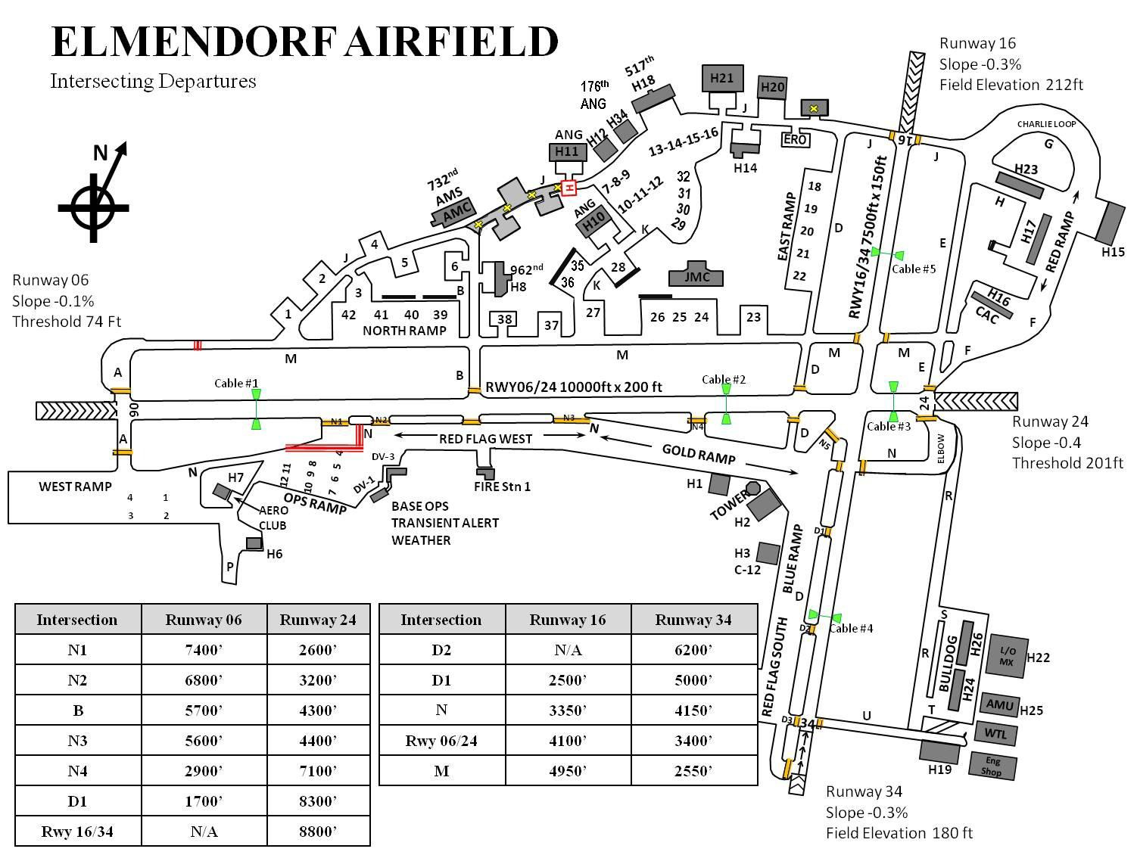

- Intersecting Runway Operations:

  - After landing, an aircraft may be asked if they are able to hold short of the intersection to allow continuing full runway operations for the intersecting runway. Only one aircraft may be requested to hold short of the intersection. This procedure is not authorized when the runway is wet, wet with chemical or has been issued an RCR value.

  - Pilots requested to hold short of the intersecting runway MUST inform ATC if unable to comply.

Section D. IFR Procedures

- Precision Approach Radar (PAR) Approaches/Monitoring:

  - RFC hours will be published via NOTAM by AM each Thursday for the upcoming week. During these times the RFC will provide dual PAR approach capability to the maximum extent possible (this capability will be contingent upon current manning and equipment functionality). Airport surveillance radar (ASR) approaches are not available at Elmendorf Airfield. Each final controller may monitor only two aircraft, two flights of two, or one flight of four aircraft. Fighter aircraft will cease Radio Detection and Ranging (RADAR) operations at 10 mile final when conducting an instrument/precision approach. Activation of RADAR while on final approach interferes with the reception/display of the PAR equipment and degrades controller capabilities.

  - Due to extensive light civilian aircraft operations in the vicinity of the Runway 06 final approach course, the RFC will monitor all instrument approaches during hours of operation.

  - The RFC will use the following phraseology when monitoring TACAN approaches: “RADAR MONITORING NOT AVAILABLE, REMAIN THIS FREQUENCY FOR TRAFFIC ADVISORIES.”

Radar/In-Trail Recovery Procedures:

  - The flight lead will coordinate with the controlling ATC agency prior to taking spacing. Spacing for each aircraft will be a minimum of 6,000’ and a maximum of 2 miles in-trail.

  - In the event of a missed approach/go around/break out procedure, pilots will be responsible for maintaining separation with other aircraft in their flight and will execute the missed approach as published or as directed by ATC.

  - In the event of lost communication, pilots will be responsible for maintaining separation with other aircraft in their flight and will execute appropriate lost communication procedures.

  - Radar trail recoveries will not terminate in a PAR approach and are limited to a maximum of four aircraft.

- IFR Breakout Instructions (for Aircraft Returning to Approach Control). When the primary arrival runway at Anchorage International is Runway 15, coordination will be accomplished for A11 approval prior to issuance of this breakout procedure. Additionally, this procedure may apply to straight-in approaches and will be applied at or prior to the final approach fix (FAF). Unless otherwise coordinated, "Break-Out" means: TURN LEFT HEADING 360, CLIMB MAINTAIN 3,000 Traffic conditions may dictate alternate instructions.

52

- IFR Go-Around Instructions. These instructions are also referred to as the “ROMEO” (for base assigned aircraft) and will be applied when aircraft are inside the final approach fix. “TOWER CLEARANCE CANCELED/NOT RECEIVED/GO AROUND (reason) CLIMB ON RUNWAY HEADING, MAINTAIN AT OR BELOW 1,200’ UNTIL THE DEPARTURE END OF RUNWAY (VMC) THE EDF 239/0.6 DME (IMC), OR AS DIRECTED BY EDF TOWER. CLIMB TO 3,000’, UPON PASSING 900’ AND THE DEPARTURE END, TURN LEFT HEADING 290 AND EXPECT RADAR VECTORS. IN THE EVENT OF LOST COMM PROCEED DIRECT TO HOBBS (EDF 304/013) AND HOLD AS PUBLISHED.”

- Standard Missed Approach/Climb-out Procedures. For aircraft executing missed approach/low approach/stop-n-go/touch-n-go/option/go-around, the following standardized climb out procedures shall be used. This procedure shall be referred to as “ROMEO” in communications to base assigned aircraft; otherwise, the entire procedure will be passed. The procedure is:

  - For Runway 06. “AFTER COMPLETION OF LOW APPROACH/STOP-AND- GO/TOUCH-AND-GO/GO-AROUND/OPTION, FLY RUNWAY HEADING, MAINTAIN AT OR BELOW 1,200’ MEAN SEA LEVEL (MSL) UNTIL DEPARTURE END OF RUNWAY (VMC), THE EDF 239/0.6 DME (IMC), OR AS DIRECTED BY EDF TOWER/RFC. CLIMB TO 3,000’ MSL, UPON PASSING 900’ MSL AND THE DEPARTURE END, TURN LEFT HEADING 290 AND EXPECT RADAR VECTORS. IN THE EVENT OF LOST COMM PROCEED DIRECT TO HOBBS (EDF 304/013) AND HOLD AS PUBLISHED.”

    - When R2203 is HOT. MAINTAIN 1,200’ MSL UNTIL DEPARTURE END OF RUNWAY (EDF R-239/.6 DME FIX) OR AS DIRECTED BY EDF ATCT/RFC, THEN CLIMB AND MAINTAIN 3,000’ MSL, TURN LEFT HEADING 290 AND REMAIN WITHIN
2.5 DME OF THE EDF TACAN UNTIL ESTABLISHED ON HEADING 290 TO REMAIN CLEAR OF R-2203, THEN PROCEED DIRECT HOBBS.” THIS PROCEDURE MAY BE REFERENCED AS THE “RESTRICTED AREA CLIMB-OUT TO HOBBS.”

  - For Runway 24. “AFTER COMPLETION OF LOW APPROACH/STOP-AND- GO/TOUCH-AND-GO/GO-AROUND/OPTION, CLIMB ON RUNWAY HEADING, MAINTAIN AT OR BELOW 1,200’ MEAN SEA LEVEL (MSL) UNTIL DEPARTURE END OF RUNWAY (VMC), THE EDF 239/2.2 DME (IMC), OR AS DIRECTED BY EDF TOWER/RFC. CLIMB TO 3,000’ MSL, TURN RIGHT HEADING 360, WITHIN 4 DME OF THE ELMENDORF TACAN UNTIL REACHING A HEADING GREATER THAN 320 AND EXPECT RADAR VECTORS. IN THE EVENT OF LOST COMM PROCEED DIRECT TO HOBBS (EDF 304/013) AND HOLD AS PUBLISHED.”

IFR Departures:

  - Clearances. Pilots will contact Elmendorf Clearance Delivery (128.8/306.925) to obtain their IFR or special visual flight rules (SVFR) clearance. To avoid departure delays, every effort should be made to resolve clearance discrepancies prior to taxiing for departure. Aircraft can expect delays in excess of 15 minutes if changes to IFR clearances are made within 10 minutes of estimated time of departure.

    - If Clearance Delivery and AM Operations do not have a clearance in the system for a specified call-sign, Clearance Delivery will advise the pilot/flight lead to contact their squadron operations for correction or re-filing of clearance. Clearance Delivery, through coordination with AMOPs, can amend clearances that are in the flight data input/output (FDIO) system. Aircrew may also contact AM via pilot to dispatch (PTD) for flight plan corrections.

    - When two 2-ships request to depart as a single flight of four (for example, Wolf 01, 2/F- 22s and Leopard 01, 2/F-22s), Clearance Delivery will issue the clearance to flight lead and issue a separate squawk to each element. For ATC purposes, this flight will be controlled as a flight of 4/F-22s (for example, Wolf 01, 4/F-22s). Tower will activate the second element’s flight plan by sending a departure message.

Runway 06 IFR Clearances:

      - IFR clearances for all non-fighter aircraft departing Runway 06 will normally be “Callsign, CLEARED TO (destination airport) AS FILED, ON DEPARTURE TURN LEFT HEADING 290, CLIMB AND MAINTAIN FL200, EXPECT (requested FL) 5 MINUTES AFTER DEPARTURE, DEPARTURE FREQUENCY 118.6/290.5, SQUAWK XXXX.”

      - When R-2203 is HOT, non-fighter aircraft departing Runway 06 will be instructed to “Callsign, CLEARED TO (destination airport) AS FILED, ON DEPARTURE TURN LEFT HEADING 290, REMAIN WITHIN 2.5 DME OF THE EDF TACAN UNTIL ESTABLISHED ON HEADING 290 TO REMAIN CLEAR OF R-2203.“

51.1.3.3. Fighter aircraft departing on the EEEGL SID from Runway 06 when R-2203 is HOT will be issued the Restricted Area Climb-out, “TURN LEFT HEADING 290, REMAIN WITHIN 2.5 DME OF THE EDF TACAN UNTIL ESTABLISHED ON HEADING 290 TO REMAIN CLEAR OF R-2203, INTERCEPT THE EDF 320 RADIAL OUTBOUND, UPON REACHING 6 DME, TURN RIGHT DIRECT FITER AND RESUME EEEGL SID.” NOTE: Base assigned fighters may be issued, “EXECUTE RESTRICTED AREA HOT CLIMB-OUT TO FIETR.”

51.1.3.4. When R2203 is HOT with BUFFER (3 NM separation from R2203 required), IFR departures from Runway 06 are not authorized. Coordination with Anchorage Approach Control may be accomplished for a Runway 24 departure with a heading that establishes 3 NM of separation from R2203.

54

Runway 34 IFR Clearances:

      - Fighter aircraft departing Runway 34 on the EEEGL standard instrument departure (SID) will fly the procedure as published. There are no restrictions to fighter departure clearances when R2203 is HOT.

      - Non-fighter aircraft departing Runway 34 will be instructed to “Call-sign, CLEARED TO (destination airport) AS FILED, ON DEPARTURE TURN LEFT HEADING 290.”

      - When R2203 is HOT with BUFFER (3 NM separation from R2203 required), IFR departures from Runway 34 are not authorized. Coordination with Anchorage Approach Control may be accomplished for a Runway 24 departure with a heading that establishes 3 NM of separation from R2203.

Runway 24 IFR Clearances:

      - IFR clearances for all non-fighter aircraft departing Runway 24 will normally be “Call- sign, CLEARED TO (destination airport) AS FILED, ON DEPARTURE TURN RIGHT HEADING 360, REMAIN WITHIN 4 DME OF THE EDF TACAN UNTIL ESTABLISHED ON HEADING GREATER THAN 320, CLIMB AND MAINTAIN FL200, EXPECT (requested FL) 5 MINUTES AFTER DEPARTURE, DEPARTURE FREQUENCY 118.6/290.5, SQUAWK XXXX.”

      - Fighter aircraft departing on the EEEGL SID from Runway 24 will be issued “TURN RIGHT HEADING 360, REMAIN WITHIN 4 DME OF THE EDF TACAN UNTIL ESTABLISHED ON HEADING GREATER THAN 320. INTERCEPT EDF R-334, RESUME THE EEEGL SID”. If a pilot is unable to execute this restriction advise A11 and coordinate an alternate release.

      - Base assigned fighters departing on the EEEGL SID from Runway 24 will be issued “CLEARED TO ELMENDORF AIRFIELD VIA THE (SP) AS FILED”. On departure, these aircraft will TURN RIGHT HEADING 360, REMAIN WITHIN 4 DME OF THE EDF TACAN UNTIL ESTABLISHED ON HEADING GREATER THAN 320. INTERCEPT EDF R-334, RESUME THE EEEGL SID.

- Runway 16 Departures. IFR departures on Runway 16 are prohibited. Aircraft departing Runway 16 must maintain VFR, enter a left downwind and activate their IFR flight plan with ANC Approach Control once they are north of the field.

- Fighter Flight Elements. When two 2-ships request to depart as a single flight of four (for example, Wolf 01, 2/F-22s and Leopard 01, 2/F-22s), Clearance Delivery will issue the clearance to flight lead and issue a separate squawk to each element. For ATC purposes, this flight will be controlled as a flight of 4/F-22s (for example, Wolf 01, 4/F-22s). Tower will activate the second element’s flight plan by sending a departure message.

Takeoff and Landing Priorities:

  - All aircraft will be sequenced to provide an orderly flow of air traffic in accordance with FAAO 7110.65 and the following local priorities:

    - In-flight emergencies.

    - Actual air defense/Scramble//Airborne Order Launches. NOTE: Actual/Practice scramble aircraft are required to be airborne no earlier than 5 minutes prior to proposed departure time and no later than the proposed departure time.

    - Rescue Coordination Center directed launch or aircraft using the call sign “RESCUE.”

    - Air evacuation (when requested) ambulance/Lifeguard.

    - OPEN SKIES aircraft.

    - DV departures and arrivals (DV code 6 or higher).

    - Practice airborne orders (ABO)/Scramble Launches.

    - RED FLAG recovery operations.

    - Departures with Controlled Takeoff (CTO) times. NOTE: Requests for a CTO should be passed to ground control on initial contact. If conditions preclude meeting a CTO, the Tower will advise the aircraft of the length of expected delay.

    - RED FLAG launch operations.

    - Other military and commercial traffic supporting the military mission (Full stop landings will receive priority over practice approaches).

    - General Aviation traffic (IFR or VFR). NOTE: Elmendorf Airfield is a military airfield. Normal Circumstance provides military and commercial traffic supporting the military mission priority over all other traffic.

56

Section F Flight Planning Procedures

- Filing Flight Plans. All aircraft that depart Elmendorf Airfield MUST file a flight plan. Flight plan filing procedures will be in accordance with AFIs 11-202, General Flight Rules; 11- 401, Flight Management; and 13-204, Vol 3, and other applicable Wing Instructions or agreements. Flights remaining within Anchorage Air Route Traffic Control Center’s (ZAN ARTCC) airspace may utilize the DD Form 175, Military Flight Plan, when filing. Flights that depart ZAN ARTCC, regardless of destination, must file a DD Form 1801, DoD International Flight Plan. A flight that departs and returns to Elmendorf with no en-route stops is considered a local area flight. These flights may use stereo plan (SP) routes and will file their flight plan using PEX ©. Aircrew will confirm successful entry of SP routes by contacting AM. A listing of SP routes is located in AM. AM personnel will use the ATLAS flight tracking program to track all flight plans.

  - Deviations. Six Mile Lake Sportsman’s Club aircraft may file flight plans with an Federal Aviation Administration (FAA) Service Station when departing from Six Mile Lake. All other deviations from flight planning procedures require the 3d Operations Group Commander (3 OG/ CC) or FAA approval. AM cannot process secure flight plans, therefore responsibility is placed upon flight crews and their squadrons to ensure all flight plans are unclassified. Changes to processed flight plans, departure times, or arrival times will be processed in an unsecured manner.

  - Flight plans may be filed in person, by PEX or by e-mail or by fax to AM. E-mailed flight plans can be send to baseops@elmendorf.af.mil. Only Elmendorf assigned aircraft to include the Aero Club, Alaska Regional Flight Center, and Red Flag hosted participants are authorized to fax flight plans. Faxed flight plans/changes to PEX will be followed up with a telephone call to ensure

receipt and accuracy. Agencies that fax flight plans are required to maintain the original flight plan, crew list, manifest, fuel load, weight and balance information, and other pertinent information in accordance with Air Force WEB-RIMS Records Disposition Schedule (RDS) located at https://www.my.af.mil/afrims/afrims/afrims/rims.cfm. All flight plans will be filed no later than one hour prior to proposed takeoff time. AM will not accept flight plans over the telephone/landline circuit or the pilot-to-dispatch (PTD) frequency 372.2 or 134.1. Changes to previously filed flight plans may be made and accepted via telephone or PTD radio.

    - The 517 AS and 249 AS Crews. Will fax or e-mail scanned copies of all flight plans, using DD Form 175, Military Flight Plan, or DD Form 1801, International Flight Plan – DoD, and will adhere to procedures outlined in paragraph 78, this instruction.

    - Wing Fighters. If PEX is inoperative, flight plans should be filed via fax or DD Form 175 or DD Form 1801. Squadron operations sections will verify the accuracy of flight plans with AM at least one hour prior to the aircrafts’ proposed take-off.

    - Red Flag Flights. Deployed aircraft must use local wing-flying procedures. In accordance with Red Flag and FAA requirements, all Red Flag fighter aircraft must file an SP route, to include pre-assigned Mode-3 beacon codes, and will not exceed more than two aircraft per flight plan. All other airframes are encouraged to use the SP routes. When specific mission requirements or aircraft performance characteristics prohibit flying an SP route, a DD Form 175 or DD Form 1801 will be filed with AM.

    - Aero Club, Civil Air Patrol (CAP), Federal Bureau of Investigation (FBI), and Privately Owned Aircraft (POA). Departing flights, regardless of flight rules conditions, will file a flight plan with AM. Arriving flights will consider their flight plans closed upon arrival, unless requested to remain open by the pilot. FBI aircraft will use local Aero Club procedures. All aircraft, whether they are privately owned or affiliated with any military/ government agency, will file a DD Form 175.

- Controlled Takeoff Times (CTO). Aircrew (except C-17 aircrew) departing with a CTO will annotate CTO and time of departure in the remarks section of their flight plan. C-17 aircrew will pass their requested CTO time to Ground Control after it has been calculated by the onboard mission computer.

- Real World/Practice Scrambles. The Regional Air Operations Center (RAOC) will give real world/practice scramble flight notification over the scramble line. Elmendorf Tower will input real world/practice scramble flight plans into the air traffic system. These departures will receive priority in accordance with paragraph 54 of this instruction.

- Airborne Orders. Elmendorf Tower will input flight plans into the air traffic system for all airborne orders (ABO).

76

- RED FLAG Operations. RED FLAG exercises may or may not include aircraft from other bases or countries. Due to increased traffic flow during these exercises, aircraft not participating can expect a delay of up to one hour for departures and arrivals (see paragraph 54 of this instruction for mission priorities). Information on RED FLAG departure and arrival windows will be available from AM to aid in flight planning for non-participants to help avoid delays.

- Customer Surveys. Pilots are encouraged to forward comments on local ATC, AM, and Weather services. Forms are distributed electronically to aircrew members and responses are tracked by the Airfield Operations Flight.

- Notice to Airmen (NOTAM) Procedures. All NOTAMs and Airfield Advisories concerning the Elmendorf Aerodrome are entered into the FAA NOTAM database by AM. The Elmendorf Air Traffic Control tower is the NOTAM monitoring facility.

- Flight Information Publications (FLIP). All requests for changes to FLIP accounts should be passed to AM.

Section G--Miscellaneous Procedures

- Waivers to Airfield/Airspace Criteria. Waivers not specifically addressed in this instruction will be in accordance with UFC-3-260-1, Airfield and Heliport Planning and Design, AFIs 11-230, Instrument Procedures, AFI 13-204, and PACAFI 32-1056, or other appropriate regulations. Waivers will be obtained using AF Form 4058, Airfield Operations Policy Waiver. Twenty-five percent of all airfield obstruction waivers will be reviewed quarterly and an approval request for all waivers will be submitted to PACAF on an annual basis.

- Prior Permission Required (PPR) Procedures. All non-base assigned aircraft will request PPR numbers between 24 hours and 5 days prior to arrival from AM. AMC scheduled missions do not require a PPR. Aircraft filing Elmendorf as a weather divert are exempt from this restriction.

- Arriving Air-Evac Notification. When informed of an inbound aero-medical aircraft, Tower will notify AM of the estimated time of arrival. AM will forward applicable information to required agencies.

- Emergency Landing Notification. Aircrew anticipating a landing requiring extra time on the runway will immediately notify either A11 or Elmendorf Tower of the problem and their intentions. EXAMPLES: Landing gear requiring pinning, cable engagement, or shutdown on the runway.

- Distinguished Visitor (DV) Notifications. The 673 ABW/Protocol and/or 11 AF/CCEP will provide AM with the call sign, type aircraft, date, and proposed arrival time for all DV flights. Time permitting, AM will notify 673 ABW/CP when DV aircraft are inbound to Elmendorf Airfield and will provide an estimated time of arrival (ETA). If possible, this notification will take place at least 30 minutes prior to ETA.

- Airfield Operations Board (AOB). The Wing Airfield Operations Board provides a forum for discussing, updating, and tracking various activities in support of the 3 WG’s flying mission. This board will convene quarterly and within 30 days of receipt of an official Air Traffic Systems Evaluation Program report.

  - AOB Membership. The 3 WG/CV will chair the AOB unless delegated to the 3 OG/CC. Board membership is appointed by the chairperson and includes representatives from, but not limited to, the following organizations:

    - 673 ABW/CV.

90.1.2. 176 WG/CV.

    - 3 OG/CC/DO.

    - 673 MSG/CC.

    - 176 OG/CC/DO.

    - 715 AMOG/CC/DO.

    - 3 MXG/CC/DO.

    - 176 MXG/CC/DO.

    - 673 CEG/CC/DO.

    - 477 FG/CC/DO.

    - 673 MSG/CC/DO.

    - 3 WG/SE.

    - 3 OG/OGV.

    - 673 LRG/CC/LGRF.

78

    - 525 FS/CC/DO.

    - 90 FS/CC/DO.

    - 517 AS/CC/DO.

    - 962 AACS/CC/DO.

    - 249 AS/CC/DO.

    - 212 RQS CC/DO.

    - 211 RQS CC/DO.

    - 210 RQS CC/DO.

    - 537 AS/CC/DO.

    - 144 AS/CC/DO.

    - 732 AMS/CC/DO.

    - 176 OG/OGV.

    - 176 OSS/CC/DO.

    - 3 OSS/CC/OSA/OSAM/OSAT/OSW.

    - 673/773 CES/CEO/CECC/CECD.

    - 673 CS/SCO/SCOA.

    - 673 FSS/FSCA (AERO CLUB).

    - 673 SF/SFO.

    - 673 ABW/CP.

    - 611 AOC/CODK.

    - AKRFC (ARMY).

    - ANCHORAGE ATCT.

    - ZAN ARTCC.

    - FAA AFREP/ATREP.

    - 773 LRS/CC/DO/LGRN/LGRA.

  - AOB Agenda. The AOF/CC, or designated representative, prepares the agenda and records the minutes of each AOB. The agenda should include the following mandatory items and any other pertinent issues the Wing deems appropriate:

    - Airspace (terminal, en route, and special use airspace) (Due Jun).

    - ATC/Flying procedures (new, revised, rescinded).

    - Military and/or FAA concerns.

    - Airfield Operations Flight staffing and proficiency.

    - ATCALS (flight inspection schedule; ATCALS equipment problems, status, upgrades).

    - Flight delays/diverts, and cancellations resulting from ATC/ATCALS system limitations.

    - Airfield environment to include a review of airfield activities, problems, and programs. NOTE: This requirement is in addition to the annual reviews and inspections required by other AF directives. Detailed planning and discussions of these items may be addressed at other meetings, committees, or boards.

      - Airfield waivers (permanent/temporary) number and status. Status of Annual Airfield Waiver Package. An annual review of airfield/airspace waivers will be completed and submitted to HQ PACAF by 15 September. Airbase/Wing Commanders must submit an airfield/airspace waiver review package within 90 days of accepting command and a formal review of waivers biennially thereafter to HQ PACAF.

      - Status of deteriorating airfield/runway conditions (inspection trends, FOD/tire damage comparisons).

      - Trend data collected from aircrew surveys.

      - Bird Aircraft Strike Hazard (BASH) activities (active/passive), problems encountered (base agency support/funding), bird and animal trends (survey data/strikes/BASH responses).

80

    - Status of the Airfield Driving Program (units visited, units scheduled for a visit in the upcoming quarter, changes or problems with accomplishing airfield driver’s training, runway intrusions, controlled movement area violations, runway intrusion trends).

    - Hazardous air traffic reports (HATR) filed since the last AOB.

    - Air Traffic Systems Evaluation Program Observations, Special Interest Items, Problems, and Off-Checklist Problems. NOTE: When AOB minutes include Air Traffic System Evaluation (ATSE) observations, they must be marked “FOR OFFICIAL USE ONLY.”

    - The following items require annual review in the month annotated:

      - Base instructions, Letters of Agreement, Operations Letters, OPLAN taskings (Due Mar).

      - Terminal Instrument Procedures (Due Jun).

      - Local aircraft parking plan (Due Dec).

      - Review of local aircraft priority procedures (Due Dec).

      - Review NOTAM circuit and Joint Environmental Toolkit (JET) reliability (Due Jun).

      - Review Mid-Air Collision Avoidance (MACA)/BASH Program (semi-annual) (Due Mar/Sep).

      - annual self-inspection (Due Sep).

      - ecial Interest Items (SII). (At the first AOB following the official release of the SII checklist.)

      - Annual Airfield Certification/Safety Inspection (Due Mar).

      - existing airfield waivers with emphasis on temporary waivers and associated correction plans in accordance with UFC 3-260-1, Section B1-2.2.1.1 (Due Dec).

90.3. Distribution. Distribute 3 WG Airfield Operations Board minutes to all board member organizations and to command levels through HQ PACAF/A3OF and HQ AFFSA/XV.

- Severe Weather Notification. Severe Weather Notification: The 17 Operational Weather Squadron (OWS) and Base Weather (3 OSS/OSW) cooperatively determine the potential of impending severe weather. The 17 OWS will issue weather warnings/watches/advisories via the joint environmental toolkit (JET), e-mail and phone. Base Weather personnel will call 673 ABW Command Post, Tower, AM and the Maintenance Operations Center. The 673 ABW/CP will then notify 673 and 3 Wing leadership. AM will disseminate weather warnings via the Secondary Crash Net.

Airfield Snow Removal Operations:

  - The 3 OSS Top 3 establishes snow removal priorities for the 3 WG flying window. During periods outside of the 3 WG flying window, AM will use the priority list and known AMC and transient traffic as a guideline for directing snow removal operations.

  - AM will report airfield status to Tower, 3 WG SOF, Roads and Grounds, and Equipment
44. Airfield status reporting will include current snow removal and sanding priorities, cable status, runway surface condition (RSC), runway condition readings (RCR), and time that the RCR was taken.

    - Current RSC Reports can be accessed on the JBER Home Portal Page during winter months. and may include one of the following values: Wet Runway (WR), Slush on Runway (SLR), Loose Snow on Runway (LSR), Ice on Runway (IR), Packed Snow on Runway (PSR). Conditions may also be reported as Patchy when more than one condition exists. If one of the preceding conditions is not reported, the runway is considered dry.

    - RCRs will be taken when braking action is in question due to presence of snow, ice or slush. An RCR will be reported in the range of 2-25 when surface conditions are other than dry, wet or slush on runway. Readings will also be taken for taxiways and aprons. Current RCR reports can be accessed on the JBER Home Portal Page during winter months. RCR/RSC for both runways will be broadcast via ATIS.

Hillberg Snowmaking Procedures:

  - Hillberg will contact AM (DSN: 552-2107) for approval prior to commencing snowmaking operations.

  - Hillberg will not be authorized to commence snowmaking operations during the wing flying window. Outside the wing flying window, all requests from Hillberg to make snow will be approved by the Airfield Manager or AOF/CC/DO, outside a snow event. During a snow event AM may approve snow making operations. AM will contact Base Weather to gather the

82

current winds, forecasted winds and the dew point. If approved to make snow, AM may authorize Hillberg to operate the middle machines, then top machines. During this process, if conditions deteriorate on/over the airfield, AM will have Hillberg shut down machines in reverse order (process of shutting down takes 45-75 minutes).

  - Once Hillberg is approved to make snow the Hillberg Operator will call AM hourly during the snow making process to determine if snow and/or fog are affecting the airfield.

  - If AM or Base Weather determines that Hillberg may be producing snow/fog conditions on the airfield or airfield conditions deteriorate, AM will have Hillberg shut down machines in the reverse order identified in paragraph 93.2 of this instruction. AM will be proactive in requesting Hillberg shut down their cannons because the process takes 45-75 minutes.

  - Hillberg will be approved to make snow during a snow event that is expected to last longer than two hours. Hillberg will be required to start shutting down the cannons an hour prior to the forecasted end of the snow event, unless continued snow making is approved by the Airfield Manager or AOF/CC/DO.

- BASH/Bird Watch Condition (BWC) Procedures. Refer to 3WGI 91-212, Bird and Wildlife Aircraft Strike Hazard (BASH) Program, for specific BASH procedures.

- Bird Watch Condition (BWC) Codes. The following terminology has been locally established for rapid communication of bird activity. Bird locations should be given with BWCs.

  - Condition SEVERE. Represents bird activity on or immediately above the active runway or other specific location representing a high potential for strikes. Supervisors and aircrews must thoroughly evaluate mission need before conducting operations in areas under condition SEVERE.

  - Condition MODERATE. Represents bird activity near the active runway or other specific location representing increased potential for strikes. BWC moderate requires increased vigilance by all agencies and supervisors and caution by aircrews.

  - Condition LOW. BWC LOW indicates normal bird activity on and above the airfield with low probability of bird strike hazard.

  - Declaring a Bird Watch Condition. The 3 OG/CC has delegated the Tower Watch Supervisor as the authority for declaring bird watch conditions. The Tower Watch Supervisor will coordinate with AMOPs and United States Department of Agriculture (USDA) personnel prior to declaring or changing a bird watch condition. To allow maximum flexibility for Tower and the SOF, a BWC may be declared for an approach or departure end of the affected runway.

EXAMPLE: “BWC SEVERE, departure end, Runway 34; eagle soaring at 100’ above ground level.” The 3 OG/CC (SOF) or Tower Supervisor may determine if bird activity near the primary runway constitutes a threat to flying operations. If it does not, the BWC may be lowered for the primary runway while keeping the higher BWC for the other runway. Once the dispersal teams have moved the birds and the airfield is clear, the BWC should be lowered.

  - Traffic Pattern Restrictions. The SOF will direct aircraft according to the listing below. If the SOF is absent the Tower Supervisor will be the controlling authority.

Table 95.1. Traffic Pattern Restrictions.
PHASE | BWC LOW | BWC MODERATE | BWC SEVERE
Takeoff (T/O) | Ops Normal | No Formation T/O | Prohibited w/o 3 OG/CC or higher approval
 |  | T/O only when departure routes avoid bird activity
Patterns | Ops Normal | No Fighter Formation Approaches | Aircraft will hold (Fuel Permitting)
 |  | No Practice Approaches (VFR or Instrument)
Landings | Ops Normal | No Fighter Formation Landings | Prohibited w/o 3 OG/CC approval (unless required for emergencies or to meet normal/divert fuel requirements) 3 OG/CC delegates SOF as landing authority regardless of condition
 |  | 6,000’ minimum spacing between landing aircraft
 |  | Only when arrival routes avoid identified bird activity

NOTE: The 3 OG/CC delegates the SOF as the landing authority, regardless of bird watch condition, for emergencies and to meet normal/divert fuel requirements.

SOF/Tower/AM Interface:

  - The Airfield Operations Flight Commander will provide a dedicated SOF position with radio and landline communications in the Tower. The 3 WG SOF normally occupies this position, but other units may use it upon request.

84

Tower Watch Supervisor (WS) Will:

    - Introduce him/herself to each SOF at the beginning of the SOF's tour of duty, and advise him of any conditions which may affect flying operations.

    - Assist the SOF by relaying information to aircraft, when Tower workload permits. Tower will preface these transmissions with the phrase "SOF ADVISES/DIRECTS/ REQUESTS" as appropriate.

SOFs Will:

    - Obtain a brief from AM on the current airfield status, to include mission and, if applicable, the snow removal priorities for the day. The opening SOF will obtain these briefings in person.

    - Obtain approval from the Tower Watch Supervisor to use equipment other than that specifically provided for the SOF position/operations.

    - When advice or instructions to an emergency aircraft are technical in nature or when relaying information through the controller may cause an unacceptable delay, coordinate with the Tower WS to transmit directly to the affected aircraft on ATC or guard frequencies. Such advice must be limited to that essential to prevent a mishap.

    - Ensure the Tower WS is informed of all inbound emergencies. Advise the Tower WS as soon as possible of emergencies that are likely to cause a runway closure upon landing.

    - Advise AM of changes to the flying operations and requests for changes to cables and snow removal priorities. NOTE: During winter operations, it’s important that the SOF communicate changes to the flying schedule to AM. AM will advise Equipment 44 (snow removal supervisor) to prevent or re-direct the snow removal equipment.
    - During the 3 WG fighter window the SOF will use a headset to reduce the noise level in the tower cab. The SOF will coordinate with the WS prior to passing information to other controllers unless an emergency deems otherwise.

    - Use the following landlines: x3010, x3628, 673 ABW Command Post (CP), Eielson SOF (EIL SOF), AM (BOPS), squadron direct lines (525 FS, 90 FS, 517 AS, 962 AACS, 477 FS, 176 WG), EOR SUPR, OG/CC, WG/CC, MSN DIR, MOCC, RAOC, Red Flag, ALRT, CSC, and WX OBS.

    - Coordinate with the WS prior to using the following ATC landlines: ZAN ARTCC, Anchorage Approach (APCH).

AM will:

    - Brief the SOF on airfield status to include mission and snow removal priorities for the day.

    - Perform a runway check following in-flight emergencies. The SOF may waive runway checks following in-flight emergencies for base assigned aircraft only.

- Taking of Photographs on the Airfield. All personnel requesting permission to take photographs of the airfield or facilities/aircraft on the airfield should refer to the Joint Base Elmendorf Richardson Integrated Defense Plan.

Night Vision Device (NVD) Operations:

  - Participating Units will:

    - Contact the Elmendorf AM or designated representative prior to the execution of NVD operations and will state the requested runway to be utilized. This coordination may be accomplished via phone, through remarks on the flight plan or notification to AM via PTD five minutes prior to requesting execution of NVD operations with Tower. When prior coordination is not accomplished with AM, the request may be denied.

    - Maintain radio contact with Tower throughout NVD operations. Aircraft conducting airborne operations will utilize Tower frequencies 352.05 or 127.2 for communications (normal CTAF radio calls; that is, Call Sign XX, left base, gear down 16, full stop). Ground operations will use Ground Control frequencies 275.8 or 121.8 for communications. All participating aircraft will monitor discrete interplane Frequency 382.4 for both NVD Ground and Airborne operations.

    - Act all NVD Operations at their own risk.

    - When no aircraft are parked on the East Ramp, aircrew may request approval from AM to turn off the stadium lighting in that area. If approval is granted, aircrew are responsible for turning the lights off prior to their mission and turning them back on once training is complete. AM may deny this request due to scheduled ramp activity.

Elmendorf AM will:

    - When notified of NVD operations by aircrew, confirm times are within IFR published hours (1900L-0100L), if not send NOTAM “NVG Operations on RUNWAY16/34 from XXXX to XXXX”.

    - Advise NVD operators of any conflict to their planned operations as soon as they arise.

Elmendorf Tower will:

86

    - Advise A11 and Merrill Field Tower of the aircraft callsign, type, expected duration of airborne NVD operations (that is, one approach, 15 minutes, and so forth), and the VFR beacon code.

    - Turn off all allowable airfield lighting (Force Protection permitting) as requested by the participating NVD aircrews except the rotating beacon and obstruction lighting during airborne NVD operations. During NVD Ground operations turn off Runway 16/34 lighting and lighting for Taxiways (E-J), (M2), (D-J), (D-N), and (J). When requested, covert lighting is available for Runway 16 operations and overt lighting is available for Runway 16/34 operations. NOTE: Tower Cab lighting will be set at the discretion of the WS/SC. Lighting should be set at an intensity low enough to observe participating aircraft/ground participants, yet not impede operations.

    - Provide “Preventive Control” in accordance with FAAO 7110.65 to participating aircraft by discontinuing services to non-participating aircraft landing or departing Elmendorf Airfield. Instruct non-participating aircraft to remain outside Elmendorf Class D airspace or in parking, and advise non-participating aircraft of NVD operations. If other air traffic is transitioning Elmendorf’s Class D airspace, traffic advisories will be provided to all aircraft concerned.

    - Issue advisory on the ATIS concerning type and duration of operations being conducted. Phraseology: “(AIRBORNE/GROUND) NIGHT VISION GOGGLE OPERATIONS IN EFFECT FROM (time) UNTIL (time) ZULU (Specify the portion of the airfield affected for ground operations) INBOUND VFR AIRCRAFT ADVISE ELMENDORF TOWER 10 MINUTES OUT.”

    - Suspend airborne NVD operations prior to a non-participating IFR arriving aircraft reaching the final approach fix, a VFR aircraft entering Class D airspace, or an aircraft departure. Arriving IFR aircraft require the runway lights be turned on for the landing runway not later than 15 miles from landing. NOTE: NVD ground operations need not be terminated for arriving and departing nonparticipating aircraft unless the taxi routes conflict. Use of runway/approach lights does not necessitate termination of ground operations.

    - Suspend all NVD operations at any time deemed necessary for safety reasons.

    - Advise all NVD participants prior to turning on any airfield lighting, including taxiing lights for taxiing aircraft.

    - Use the following procedures during NVD operations:

      - Ground NVD Phraseology: “GROUND NVD OPERATIONS APPROVED UNTIL FURTHER ADVISED.”

      - Airborne NVD Phraseology: “AIRBORNE NVD OPERATIONS ARE APPROVED UNTIL FURTHER ADVISED, ADVISE WHEN COMPLETE.” NOTE: Due to the absence of adequate lighting, controllers will not issue explicit takeoff or landing clearances (for example, CLEARED TO LAND) to NVD operators.

    - AIRLAND or AIRLAND combined with ground operations will be limited to no more than four aircraft.

    - Elmendorf Tower controllers will not use night vision devices.

    - Request a runway check prior to any nonparticipating aircraft’s arrival to the NVD used runway.

    - Elmendorf Tower controllers will request a Merrill extension any time NVD takeoffs or touch-and-go landings are performed from Runway 16.

    - Advise AM after all NVD operations have been completed.

Traffic Pattern Procedures:

    - The VFR traffic pattern is left traffic for Runway 06 and 16, right traffic for Runway 24 and 34. Standard pattern altitude is 1200’ MSL. Advise Tower if other than standard traffic pattern altitude will be used.

    - Participating NVD aircraft are responsible for their own wake turbulence separation.

Ground Procedures:

    - NVD Ground Operations will be conducted in a box pattern. The taxi flow will be left turns and depending on where it begins will entail taxiway Delta on the North side of taxiway Mike with a left turn onto taxiway Mike then a left turn onto Runway 34 then a left turn onto taxiway Juliet and then a left turn back to taxiway Delta. Ground operations will be limited to no more than three aircraft operating in the same area.

    - ATC has the option to allow continuous ground operations in the NVD area.

88

Figure 98.1. NVD Operations.
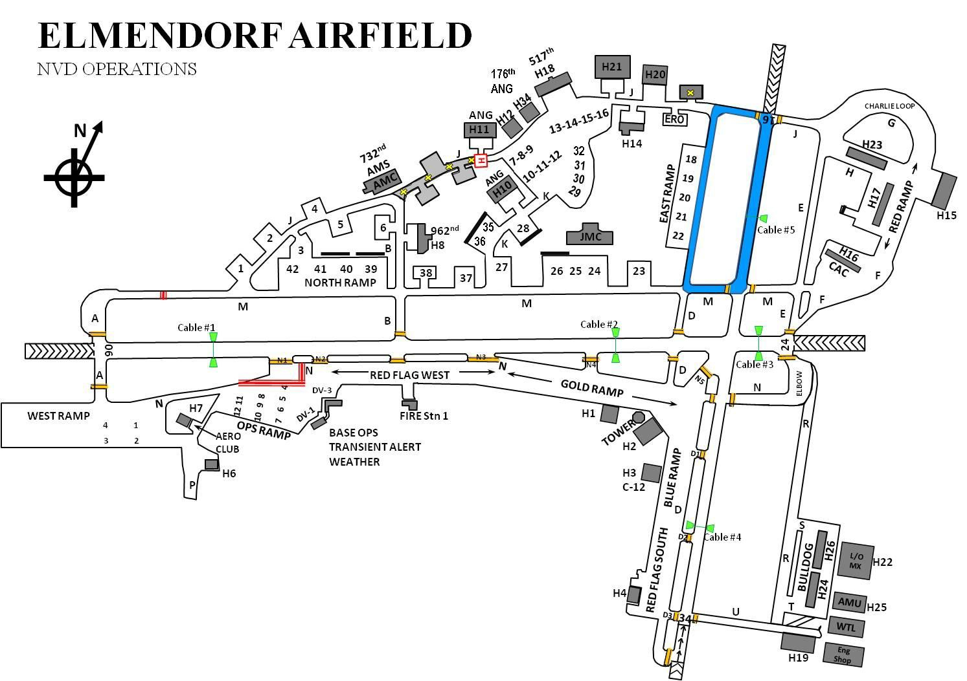

      - If traffic dictates ATC will implement positive control and require NVD operators to request approval before entering Runway 34/16 or resume taxi.

    - NVD operators will de-conflict with each other using a common frequency, while monitoring Elmendorf Ground at all times.

    - ATC will notify NVD operators of nonparticipating aircraft using taxiway Mike or Delta.

    - ATC will remain vigilant and, to the maximum extent possible, prevent non-participating vehicles from entering the NVD Ground Operating Area.

  - Weather Requirements. All NVD weather/lunar illumination requirements/minimums are in accordance with participant’s regulations. Due to Alaska’s rapidly changing solar/lunar data, contact 3 OSS/ OSW for current weather and lunar illumination conditions.

  - Restrictions for NVD Operations. During NVD operations, participating aircraft are responsible for terrain/obstruction clearance.

Fire Training Procedures:

  - Base Fire Chief Will:

    - Ensure the Tower/AM is informed of all practice fire exercises and their location at least one hour in advance. If prior notification was not received, AM has the authority to cease exercise until the airfield operations will no longer be affected.

    - Maintain direct radio contact with the Tower throughout the fire training exercise.

    - The Tower Watch Supervisor/Senior Controller has the authority to temporarily cease the exercise should safety become a factor.

Tower Will:

    - Inform the Base Fire Chief of the winds, when the one-hour notification call is received.

    - Ensure pertinent aircraft are informed of the fire training exercise.

- Runway 16/34 Operations For Heavy Aircraft. Aircraft departing Runway 34 with a wingspan greater than 98’ can anticipate possible delays due to a requirement to stop vehicle traffic on the road adjacent to the approach end of Runway 34. The Tower will activate the Arctic Warrior traffic lights for aircraft with a wingspan greater than 98’ departing from the under run or marked threshold of Runway 34. Aircrew operating an aircraft with a wingspan greater than 98’ and anticipating a Runway 34 departure must notify Ground Control ten minutes prior to taxiing. Aircraft capable of taking off past Cable 4 or more than 1000’ from the threshold (6,500’ remaining) may do so without impacting traffic on Arctic Warrior.

  - Tower controls the Arctic Warrior traffic light. This light is used for stopping vehicle traffic in the vicinity of the approach end of Runway 34 no earlier than five minutes before estimated departure time. This procedure is to prevent the possibility of vehicles and pedestrians being struck by debris due to jet blast. If the Arctic Warrior traffic lights are not working or when

92

visibility is limited/obstructed, Tower will notify Security Forces 10 minutes prior to an estimated departure in order for Security Forces to ensure traffic is stopped. Security Forces will notify Tower personnel when traffic has stopped and aircraft operations are safe to commence. Security Forces can contact tower either by LMR on the Tower Net or through their duty desk and the direct dial to the Tower.

  - As soon as vehicle traffic can resume, Tower will change the Arctic Warrior lights to green and notify the Security Forces via the direct ring line. If the Arctic Warrior traffic lights are not working, Tower will contact Security Forces when traffic may resume.

- R-2203 Procedures. Fort Richardson Live Firing Range procedures are outlined in the Joint Use Letter of Procedures for use of Restricted Area R-2203 Agreement. Contact the Airfield Operations Flight for a current copy of this letter of procedure.

